THOMAS K. KELLY, P.C.
Attorney at Law
_____________________________________________________Thomas K. Kelly
Certified Specialist - Criminal Law AZ Board of Legal Specialization
425 E. Gurley
Prescott, Arizona 86301
Telephone (928) 445-5484
Facsimile (928) 445-0414
tkkelly@kellydefense.com
December 19, 2013

STATE OF ARIZONA ROY HALL
Tom Horne, Arizona Attorney Gen. Incident Commander
Office of the Attorney General . Arizona State Forestry Div.
1275 West Washington Street 1110 W. Washington St.
Phoenix, Arizona 85007 Phoenix, Arizona 85007

ARIZONA STATE FORESTRY DIVISION RUSS SHUMATE
Scott Hunt, Arizona State Forester Incident Commander
1110 West Washington Street, Suite 100 Arizona State Forestry Div.
Phoenix, Arizona 85007 1110 W. Washington St.
Phoenix, Arizona 85007

COUNTY OF YAVAPAI TODD ABEL
Ana Wayman-Trujillo, Clerk CYFD
Yavapai County Bd. Of Supervisors 8555 E. Yavapai Road
1015 Fair Street Prescott Valley, Arizona 86314
Prescott, Arizona 86305

CITY OF PRESCOTT DARRELL WILLIS
Lynn Mulhall, City Clerk City of Prescott Fire Department
Prescott City Hall 201 S. Cortez Street
City of Prescott Prescott, Arizona 86303
201 S. Cortez Street
Prescott, Arizona 86303

CENTRAL YAVAPAI FIRE DISTRICT
Scott Bliss, Interim Fire Chief
Central Yavapai Fire Department
8555 E. Yavapai Road
Prescott Valley, Arizona 86314

Re: Notice of Claim
Decedent: Andrew Ashcraft
Date of Death: June 30, 2013
Claimant: Juliann Ashcraft
Ryder Ashcraft, Shiloh Ashcraft, Tate Ashcraft, Choice Ashcraft
Tom Ashcraft
Deborah Pfingston

Dear Public Entities and Employees:

Pursuant to A.R.S. §12-821.01, this letter serves as a formal Notice of Claim against the City of Prescott, Yavapai County, Central Yavapai Fire District and the State of Arizona (for its agency, the Arizona State Forestry Division) and their employees (collectively, “recipients” or “responsible entities”) for damages incurred by the heirs of Andrew Ashcraft, as a result of the their negligence in causing his death on the Yarnell Hill Fire on June 30, 2013. Juliann Ashcraft is the spouse of Andrew Ashcraft. Ryder Ashcraft (6 yrs), Shiloh Ashcraft (4 yrs), Tate Ashcraft (3 yrs) and Choice Ashcraft (1 yr) are the biological children of Andrew and Juliann Ashcraft. Tom Ashcraft is Andrew’s biological father. Deborah Pfingston is Andrew’s biological mother. These claimants will collectively be referred to in this letter as “Claimant.”

The wrongful death statutory beneficiaries of Andrew Ashcraft intend to pursue litigation for Andrew’s wrongful death against the above-named recipients of this claim letter if the following claim is not accepted. This Notice of Claim letter contains a fair and accurate description of the recipient’s intentional, reckless, careless and grossly negligent conduct. The full and complete facts regarding this claim are in the possession of the State of Arizona Division of Forestry, City of Prescott Fire Department, and Yavapai County Fire District and are not available to Claimant. Claimant has relied on facts contained in the Serious Accident Investigation Report dated September 23, 2013, prepared on behalf of the State of Arizona (hereinafter “SAIR Report”), the Arizona Division of Occupational Health and Safety Report released on December 4, 2013 (hereinafter ADOSH Report), and the Arizona State Forestry Division website on a page specifically referenced as “Yarnell Hill Fire Documentation” (hereinafter “Website”), as well as other information gathered through limited investigation.

This Notice of Claim serves as a reasonable foundation for the public entities and employees named above to completely investigate the circumstances of this claim and reach an informed decision regarding whether to settle this claim.

This Notice of Claim letter also contains a fair, reasonable, and firm demand for compensation. Based on the particular facts of this matter and our research regarding wrongful death settlements and awards, the amount demanded for by Andrew Ashcraft’s heirs is reasonable and will be accepted if offered by any or all recipients of this Notice of Claim letter.

- Purpose and Statement of Intent
The death of Andrew Ashcraft and his 18 fellow Granite Mountain Hotshot Crew members is a tragedy of unimaginable proportions. One of Arizona’s most horrific mass disasters, this catastrophe leaves a devastating wake of sorrow, anguish, frustration, economic ruin and a hole that can never be filled in Claimant’s life.

Claimant seeks compensation from those who caused this travesty, and also non-monetary relief so that history will not repeat itself. Claimant is sensitive and appreciative of the enormous outpouring of financial and emotional support from members of the community and throughout the world. Claimant hopes that changes can be accomplished through this claim process and remains willing to discuss a variety of concepts other than monetary compensation as part of resolution of this claim. Such concepts include:

- adopting necessary policy, procedural and protocol changes in state and local government fire suppression agencies to ensure the safety of firefighters during future wildland fires in Arizona;

- adopting, incorporating, and funding specific safety standards and equipment to enhance the protection of wildland firefighters during future wildland fire suppression efforts in Arizona;

- developing and funding an educational program with its curriculum outlining the environmental and human factors causing the death of the Granite Mountain Hotshot Crew on the Yarnell Hill Fire and further, provide adequate funding for its presentation to current and future wildland firefighters in Arizona on a yearly basis; and

- funding annual scholarships for individuals in need of financial assistance to undergo wildland fire suppression training and education in the name of Claimant’s decedent and his fallen colleagues.

Claimant is aware of the statutory requirement of making a specific sum certain monetary demand for which the claim can be settled. This letter contains such sum certain demands which, if timely tendered, will resolve the case. But it is sincerely hoped that recipients will participate in a global settlement discussion and/or mediation where non-monetary issues can be discussed as alternatives and/or offsets to the financial demands made in this letter.

Claimant believes the most productive way of resolving these claims and bringing peace and closure would be for recipients to engage in pre-suit mediation. Had time allowed, Claimant would have explored this option before serving formal notice of this claim. However, the strictures of Arizona’s statutory scheme for making claims against public entities require this notice be served within 180 days and this letter complies with that mandate. Notwithstanding, Claimant invites the parties to contact Claimant’s counsel and advise if they are willing to participate in pre-suit mediation with decisionmakers capable of making financial and policy decisions.

It is hoped that through this action positive social change can be achieved in connection with global resolution of these claims. Claimant and the other families devastated by this disaster deserve at least that much.

- Summary of Facts
On Friday afternoon, June 28, 2013, a lightning strike caused a small fire on a ridge west of Yarnell, Arizona. Designated the “Yarnell Hill Fire” the responsibility for management of suppression efforts was assigned to the State of Arizona Forestry Division. Given the small size and complexity of the fire, an employee of the State of Arizona, Russ Shumate, a Type 4 Incident Commander was assigned the responsibility of putting out the fire. On Friday, Mr. Shumate made decisions regarding the suppression of the fire from his office in Prescott, Arizona. That afternoon, Mr. Shumate declined an offer from the State of Arizona to send firefighting resources to suppress the fire on Friday night. Shumate, however, ordered a small contingent of firefighters for Saturday morning. Mr. Shumate arrived at the location of the fire Saturday morning, June 29, 2013.

Mr. Shumate’s efforts to control the fire on Saturday failed. Late in the afternoon he ordered a large helicopter and a large air tanker in an effort to control the expanding fire. Due to wind conditions at the aircraft were not able to take off to drop retardant on the Yarnell Hill Fire. At around 5:43 p.m. the State dispatcher offered Shumate the services of a very large air tanker (VLAT) located in Albuquerque, N.M. The VLAT carries 11,200 gallons of retardant – Mr. Shumate declined the offer to use the VLAT and an air drop of retardant was not made on Saturday afternoon. By Saturday evening Shumate lost control of the fire and it grew to about 100 acres. With the fire out of control, Shumate ordered a Type 2 Incident Management Team and additional resources for the next morning.

On June 30 members of the Type 2 Incident Management Team began arriving in Yarnell. The Incident Commander was Roy Hall. Central Yavapai Fire Department Captain, Todd Abel was the Operations Section Chief. Prescott Fire Department Wildland Division Chief, Darrell Willis was assigned the position of Structural Protection Group 2 Supervisor. Also on Sunday morning, the Granite Mountain Interregional Hotshot Crew (“IHC”) and Blue Ridge IHC were deployed to the fire. Granite Mountain IHC is part of the City of Prescott Fire Department, Wildland Fire Division supervised by Chief Darrell Willis. Granite Mountain IHC is the only Type I, Interregional hotshot crew in the United States associated with a Municipal Fire Department. The Blue Ridge IHC is a United States Forest Service Hotshot Crew from Coconino National Forest.

The transition of Incident Management Teams occurred at 10:22 a.m. on Sunday morning. Critical positions in the team, including Safety Officer and Planning Section Chief were not filled at the time of transition. Communication problems existed between all aspects of the suppression efforts on the Yarnell Hill Fire. Throughout the day, as fire behavior increased and conditions became critical, the Incident Command Team became overwhelmed with resulting confusion and fear. As structures in Peeples Valley and Yarnell became threatened, Incident Command failed to place the safety of firefighters as its utmost priority. While moving its Incident Command Post due to erratic and extreme fire behavior, Incident Command failed to notify the Granite Mountain IHC of the impeding danger. The death of Andrew Ashcraft and eighteen other members of the Granite Mountain HIS occurred at approximately 4:45 p.m. on June 30, 2013.

- Legal Duties
  - Negligence
    - The Law
Negligence is a breach of the duty of reasonable care that actually and proximately causes injury. Shafer v. Monte Mansfield Motors, 91 Ariz. 331, 333, 372 P.2d 333, 335 (1962). “Duty” refers to the issue of whether the defendant is obligated to take any action to protect the plaintiff. See Markowitz v. Ariz. Parks Bd., 146 Ariz. 352, 355, 706 P.2d 364, 367 (1985). Duty is frequently analyzed in terms of foreseeability. More specifically, “a duty of care . . . extends to potential victims [within] the zone of foreseeable risk.” Rossell v. Volkswagen of Am., 147 Ariz. 160, 164, 709 P.2d 517, 524 (1985).
The duty of care is breached when a defendant fails to act with “reasonable care under the circumstances.” Markowitz, 146 Ariz. at 356, 706 P.2d at 368. Breach is analyzed using an objective standard; courts frequently ask whether a particular defendant behaved in the same way a person of “ordinary prudence” would in the same situation. See Morris v. Ortiz, 103 Ariz. 119, 121, 437 P.2d 652, 654 (1968). In practice, this objective standard involves a “risk/benefit analysis” that weighs the burden of the conduct against the chance and likely severity of any harm to plaintiff. Rossell, 147 Ariz. at 164, 709 P.2d at 521.
Causation has two elements. First, there is the “cause in fact.” Arizona has adopted the “but for” test for cause in fact: “cause in fact exists if the defendant’s act helped cause the final result and if the result would not have happened without the defendant’s act.” Ontiveros v. Borak, 136 Ariz. 500, 505, 667 P.2d 200, 205 (1983). Closely related, Arizona courts also consider whether the defendant’s act was a “substantial factor” in bringing about the plaintiff’s injury. Thompson v. Sun City Community Hosp., Inc., 141 Ariz. 597, 606, 688 P.2d 605, 614 (1984).
Second, there is “proximate cause.” The Arizona Supreme Court has defined proximate cause as “that which, in a natural and continuous sequence, unbroken by any efficient intervening cause, produces an injury, and without which the injury would not have occurred.” McDowell v. Davis, 104 Ariz. 69, 71, 448 P.2d 869, 871 (1968). As a practical matter, proximate cause is “determined upon mixed considerations of logic, common sense, policy and precedent.” Nichols v. Phoenix, 68 Ariz. 124, 136, 202 P.2d 201, 208 (1949). As part of this analysis, great weight is usually placed on the foreseeability of the plaintiff’s injury. Markowitz, 146 Ariz. at 358, 706 P.2d at 370.
Finally, negligence requires damages. See Linthicum v. Nationwide Life Ins. Co., 150 Ariz. 326, 330, 723 P.2d 675, 679 (1986). Damage awards are intended to compensate plaintiffs for losses caused by defendants’ negligent conduct. Damage awards should place the injured person in “as nearly as possible in the condition he would have occupied had the wrong not occurred.” Felder v. U.S., 543 F.2d 657, 667 (9th Cir. 1976).
The government entities will be liable for the acts of their employees under the doctrine of respondeat superior and principles of agency. Under the doctrine of respondeat superior, an employer is vicariously liable for the behavior of an employee when the employee was acting within the course and scope of employment. See Restatement (Second) of Agency § 219. An employee’s conduct is within the course and scope of employment if: (1) it is the kind of conduct the employee is employed to perform; (2) it occurs substantially within the authorized time and space limit of the employment; and (3) it is actuated at least in part by a purpose to serve the employer. See Smith v. Amer. Express Travel Related Servs. Co., 179 Ariz. 131, 135, 876 P.2d 1166, 1170 (App. 1994); Restatement (Second) of Agency § 228.
The government entities will also be liable to the Claimant for negligent hiring, training and supervision of involved personnel. An employer may be liable for harm caused by its employee if it is negligent or reckless in the supervision of the employee. See Kassman v. Busfield Enterprises, Inc., 131 Ariz. 163, 166, 639 P.2d 353, 356 (App. 1981); Restatement (Second) of Agency § 213. An employer may also be liable for its negligence in hiring or retaining an employee. See Duncan v. State, 157 Ariz. 56, 59, 754 P.2d 1160, 1163 (App. 1998); Humana Hosp. v. Superior Court, 154 Ariz. 396, 400, 742 P.2d 1382, 1386 (App. 1987); In re Sproull, 2002 Ariz. Lexis 45 (2002) (negligent retention); Natseway v. Tempe, 184 Ariz. 374, 909 P.2d 441 (App. 1995) (negligent training).
Finally, the public entities’ and their employees’ violation of several statutes, regulations, guidelines and written polices designed to protect the health and safety of persons like Andrew Ashcraft constitutes negligence per se. See Brannigan v. Raybuck, 136 Ariz. 513, 517, 667 P.2d 213, 217 (1983); Orlando v. Northcutt, 103 Ariz. 298, 300, 441 P.2d 58, 60 (1968).

    - Analysis

On June 30, 2013, the City of Prescott, Yavapai County, Central Yavapai Fire District and the State of Arizona, their relevant agencies, departments, officials, employees and agents negligently caused the death of Andrew Ashcraft during the Yarnell Hill Fire. Andrew Ashcraft was a member of the Granite Mountain Interagency Hotshot Crew, a municipal hotshot crew funded, maintained and trained by the City of Prescott. On June 30, 2013, the Granite Mountain Interagency Hotshot Crew was deployed to
suppress a wildfire near the vicinity of Yarnell, Arizona. The lightning fire started and was burning on lands held in trust and managed by the State of Arizona. The Arizona State Forestry Division was responsible for management, control and suppression of the fire, but critical errors by Yavapai County, Central Yavapai Fire District and City of Prescott also played a causative role in causing Andrew Ashcraft’s death.

Recipients failed to exercise a standard of care which a reasonably prudent fire suppression agency would exercise in the suppression of a wildfire under conditions similar to those present during the Yarnell Hill Fire. Andrew Ashcraft’s death was preventable. Further, with the exercise of reasonable care no member of the Granite Mountain Hotshot Crew would have died on June 30, 2013. Moreover, Andrew Ashcraft was not involved in the management or decision making process associated with the suppression of the Yarnell Hill Fire. He was not in charge of any suppression activities of the Granite Mountain Interagency Hotshot crew. Andrew Ashcraft’s actions on June 30, 2013, cannot be considered as a contributed cause to his death.

During the Yarnell Hill Fire, the liable public entities and employees failed to adhere to the standard of care adopted by responsible wildland fire suppression agencies throughout the United States. The public entities violated recognized guidelines, policies and procedures approved and adopted for the safe suppression of wildland fires including, but not limited, to: (1) the 10 Standard Firefighting Orders (recognized and adopted by the U.S. Forest Service, Interagency Standards for Fire and Fire Aviation Operations, NFES 2724 (Jan. 2013)); (2) the 18 Watch Out Situations (recognized and adopted by the U.S. Forest Service, Interagency Standards for Fire and Fire Aviation Operations, NFES 2724 (Jan. 2013)); (3) Arizona State Forestry Division – Standard Operational Guideline 701 Fire Suppression and Prescribed Fire Policy, and (4) A.R.S. § 23-403(A)(Employers Duty to Maintain Safe Workplace).

The public entities and employees failure to adhere to the standard of care outlined by these well- established and accepted principles, guidelines and statute negligently caused the death of Andrew Ashcraft.

With the limited disclosure available to Claimant described above, the following willful, reckless, negligent and careless acts supporting this claim each contributing to the wrongful death of Andrew Ashcraft and other members of the Granite Mountain IHC:

- The state failed to assemble and engage an appropriate initial attack on the small lightning fire creating a situation that later placed hundreds of firefighters at risk and caused the death of the Granite Mountain IHC. On June 28, 2013, the fire could have been easily controlled with minimal, effective suppression efforts. The miscalculation of risk associated with the small lightning fire resulted in a subsequent life threatening event; (ADOSH Report)

- After state’s initial efforts to control the fire failed, it dispatched a skeleton management team to direct firefighting operations. The team lacked sufficient resources to adequately suppress the fire. When it assumed control on June 30, 2013, the state’s “Type 2 Short” Incident Management Team lacked “safety officers” and “division supervisors.” The absence of these required positions contributed to a breakdown in communications during the critical minutes before Andrew Ashcraft died; (SAIR Report)
- After the transfer of the fire from the Type 4 Team to the larger Type 2 (Short) Team, the Incident Commanders failed to conduct a Standard Complexity Analysis, an Operational Needs Assessment, or an Incident Action Plan. Moreover, key Safety Officer and Planning Section Chief positions went unfilled and other important officers arrived late for critical planning activities; (ADOSH Report)
- The mental and physical condition of the Granite Mountain IHC was not adequately considered by fire management personnel despite the fact the crew was exhausted, working on its scheduled day off and having already worked 28 days in the month of June, 2013; (ADOSH Report)
- The Incident Commander of the Type 4 team (Russ Shumate) was assigned to the fire on June 28, 2013. It is unclear whether Shumate had “eyes on the fire” as he made critical decisions regarding the initial attack phase of the fire. The IC4 determined the fire was “less than a half-acre in size, 80 percent out, active only in one corner with low spread potential and no structures or people at risk,” and the fire was “inactive, not much of a threat” and that he was “not taking action tonight” Mr. Shumate turned down offers by the state dispatcher to send suppression resources to the fire on Friday. At 7:19 p.m. Shumate also told state dispatch that he was “at [his Prescott] office until further notice.” The Incident Commander’s failed to aggressively initiate suppression efforts during the critical initial attack phase of the fire; (SAIR Report)
- Inadequate and deficient communications contributed to complications causing the death of Andrew Ashcraft. “Radio communications were challenging throughout the incident. Some radios were not programed with appropriate tone guards;” (SAIR Report pg. 2)
- Transition of Type 4 through Type 1 incident command teams in fewer than 20 hours added to the confusion and frustration communicating with Granite Mountain IHC, knowing their location at all times, and knowing their location when aircraft on scene were available to drop
retardant to slow the fire immediately before the crew’s fire shelters were deployed. Knowing the location of the Granite Mountain IHC would have saved Andrew Ashcraft’s life; (“fire management went through multiple transitions from a Type 4 to a Type 1 incident in fewer than 20 hours”) (“At the time of shelter deployment, a very Large Airtanker was on station over the fire waiting to drop retardant as soon as the crew’s location was determined”) (SAIR Report pgs. 2, 3)

- The transition of incident command teams, communication deficiencies and lack of command’s control or command of the fire lead to a mistaken belief as to the location of the
Granite Mountain IHC during the critical phase of the fire; (“Operations and other resources had concluded the Granite Mountain IHC was located in the black, near the ridge top where they had started that morning. This resulted in confusion about the crew’s actual location at the time of the search and rescue”) (SAIR Report pg. 3)

- The weather information provided to the Granite Mountain IHC was not clearly communicated; (“In retrospect . . . [i]t is possible they may have interpreted the early wind shift as the anticipated wind event.”) (SAIR Report pg. 3)

- Full air attack responsibilities over the Yarnell Hill Fire were deficient contributing to the death of the Granite Mountain IHC; (“The Aerial Supervision Module working the fire was very busy fulfilling leadplane duties, which limited their ability to perform full Air Attack responsibilities over the fire at the same time.”) (SAIR Report pg. 3)

- Shumate (ICT4) had worked 28 days straight as of June 28, 2013. On June 29, 2013, he worked a shift that would last for more than 30 hours. Transition of the fire suppression efforts between Shumate and Roy Hall (ICT2) occurred after Shumate had been awake for more than 24 hours. The Incidence Response Pocket Guide advises that 24 hours without sleep impacts decision making abilities and situational awareness. Mr. Shumate was exhausted at the time of transition impairing his decision making ability and situational awareness impacting the proper transition of the fire to Hall. Other team members failed to notice and correct this condition; (ADOSH Report)

- The Incident Management Team failed to contain the Yarnell Hill Fire before the start of the critical burn period beginning at 10:00 a.m. on Saturday, June 29, 2013; (at 7:40 p.m. on Friday, June 28, 2013, “ICT4 notes the fire is less than a half-acre in size, 80 percent out,
active only in one corner, with low spread potential and no structures or people at risk.”). Russ Shumate decided not to suppress the one-half acre fire during the evening and night of June 28, when temperatures are lower, humidity is higher, and decreased winds, but instead decided to begin suppression efforts the next morning, losing a critical head-start on fire suppression; (SAIR Report pgs. 11 & 12)

- The Incident Management Team failed to contain the Yarnell Hill Fire before the start of the critical burn period beginning at 10:00 a.m. on Sunday, June 30, 2013. On Saturday morning, Shumate requested two single engine airtankers (SEATS). The Wickenburg SEAT Base was not operating and the tankers were located a significant distance from the fire. Each tanker made two drops on the two-acre fire and then were released at 2:42 p.m. - during the critical burn period. Later, Shumate changed his mind and requested the two SEATS and Air Attack return to the fire. Due to availability, only one SEAT and an air attack plane returned to the fire. After the fire jumped its control line on the east flank, Shumate then requested a Type 1 Heavy Helitanker and Large Air Tanker. However, the two aircraft requested were not able to drop on the fire due to wind conditions. Mr. Shumate was then offered a very large air tanker with a capacity of 11,400 gallons of retardant. As the fire suppression efforts were rapidly deteriorating, the ICT4 declined the offer to use the VLAT at 5:50 p.m. At this time, the fire was growing and threatening the town of Yarnell; (SAIR Report pgs. 12 & 13)

- On June 30, 2013, the Incident Management Team identified the Boulder Springs Ranch as “an excellent safety zone.” (SAIR Report pg. 15). The Boulder Springs Ranch was surrounded by unburned fuel, heavy brush and terrain which did not make it an “excellent” safety zone. To exacerbate the misinformation, in order to access the designated safety zone, the Granite Mountain IHC would be required to leave the safety of the black and traverse steep, rocky, difficult terrain in thick, heavy, unburned chaparral fuel. Granite Mountain IHC lacked necessary maps to properly determine the distances between their safety zone in the black and the Boulder Springs Ranch. The Boulder Springs Ranch was not a “bomb proof” or “excellent” safety zone as described and designated by Incident Command; (ADOSH Report)

- The transition between the Type 4, ICT and Type 2, ICT occurred at 10:22 a.m. on June 30, 2013. The transition took place within a short period of time and without the ICT2 and ICT4 conferring for an acceptable length of time. Moreover, the transition occurred at an inappropriate time of day – the beginning of the critical burn period. This transition violated accepted standards of care for the transition of Incident Command Teams resulting in errors, omissions and confusion; (SAIR Report pg. 16).

- The ICT failed to complete a timely Fire Complexity Analysis; (ADOSH Report)

- On June 30, 2013, as weather conditions were changing dramatically, Incident Command (Roy Hall) “chose to evacuate the command post but allowed the Granite Mountain IHC to continue to work downwind of a rapidly progressing wind driven fire;” (ADOSH Report).

- In directing suppression efforts, Mr. Hall identified the protection of “non-defensible structures and pastureland” as a higher priority than the safety of firefighters. At the time, the
Incident Command Team “knew that suppression of extremely active chaparral fuels was ineffective and that wind would push active fire toward non-defensible structures;” (ADOSH Report)

- Due to the failure to promptly remove firefighters from dangers associated with the rapidly spreading fire, the Incident Command Team violated established fire suppression policies causing the death of the Granite Mountain IHC and exposing other firefighters to risk of “smoke inhalation, burns and death;” (ADOSH Report)

- Mr. Hall failed to fill the necessary Safety Officer and Planning Section Chief positions on his Type 2, Incident Command Team resulting in the Granite Mountain IHC not having critical maps readily available during their suppression efforts; (ADOSH Report)

- The failure to fill the Safety Officer position failed to provide the Granite Mountain IHC with information from a safety officer who “would have viewed the fire and fire line assignments from a safety viewpoint;” (ADOSH Report)

- Mr. Hall’s Incident Command Team lacked necessary cohesiveness and consistent communications with suppression personnel on the ground and in the air; (ADOSH Report).

- The Incident Command Team failed to provide the Granite Mountain IHC with a place of employment free from recognized hazards that would cause or would likely cause death or serious physical harm, in that the ICT implemented suppression strategies that prioritized protection of non-defensible structures and pastureland over firefighter safety and failed to prioritize strategies consistent with the Arizona State Forestry Division – Standard Operational Guideline 701 Fire Suppression and Prescribed Fire Policy, when the ICT knew their suppression efforts were ineffective and would push the fire toward the Granite Mountain IHC in violation of A.R.S. § 23-403(A); (ADOSH Report)

- The actions described above, were a “complete failure” of the ICT to protect the Granite Mountain IHC from exposure to smoke, burns and death at a time when the crew was located in a precarious location downwind from the fire; (ADOSH Report)

- The actions of the ICT violated the Arizona State Forestry Division, Standard Operational Guideline 701 by failing to adhere to the basic requirement that “the protection of human life is the single, overriding suppression priority;” (ADOSH Report)

- On June 30, 2013, The ICT knew that fire, wind and fuel conditions transitioned the Yarnell Hill Fire to an “extended attack,” suppression efforts were ineffective, defense of structures was not possible, and the Granite Mountain IHC was working downwind in these most dangerous conditions. “Notwithstanding this knowledge, throughout the afternoon (June 30, 2013), and in disregard of its own requirement to prioritize firefighter safety, fire management failed to re-evaluate, re-prioritize and update suppression efforts and failed to promptly remove [Granite Mountain IHC] working downwind of the fire resulting in multiple … deaths;” (ADOSH Report)

- The Arizona State Forestry Division (ASFD) failed to implement its own extended attack guidelines and procedures including an extended attack safety checklist and wildland fire decision support system with a complexity analysis:

  - ASFD failed to provide a Wildfire Situation Analysis or Wildfire Decision Support System and rationale for selecting a suppression alternative to Incident Management Team 2;

  - ASFD failed to provide Roy Hall (IMT2) with clear written direction in the form of a delegation of authority letter, violating an established standard of care expected by Incident Commanders; and

  - ASFD failed to coordinate aviation resources and ground resources on the same tactical plan; (ADOSH Report)

- The City, County and CYFD joined in the failings above;

- The City, County and CYFD exacerbated the failings described above in that they failed to:

  - advocate more effective suppression efforts;

  - bring obvious risks to firefighter safety to the attention of those in command;

  - notice the fallacy of critical decision making and the exhaustion-impaired state of those responsible for such decision making; and

  - Properly evaluate and assess the training, qualifications, and experience of its firefighters before placing in management/command positions;

- On June 30, 2013, at approximately 1:00 p.m., Raul Marquez, Division Z Supervisor
abandoned his responsibilities associated with directing suppression efforts on Division Z then returned to the command post. Marquez is an employee of the Bureau of Land Management, United States Department of Interior. On the Yarnell Hill Fire Divisions A and Z joined one another. Marquez’s abandonment of his responsibilities left firefighters on Division Z without adequate supervision, support and control. Further, Marquez’s abandonment of his responsibilities adversely affected communications, suppression efforts and the safety of firefighters in the adjoining Division A, including the Granite Mountain IHC; (ADOSH Report) and

- On June 30, 2013, at approximately 3:58 p.m., Air Attack, Rory Collins, left the fire
without explanation turning tactical operations over to “Bravo 33’ who was very busy dealing with lead plane duties. Collins had been communicating with Division A Supervisor and knew the location of the Granite Mountain IHC. This information was not communicated to Bravo 33 when Collins left the fire. Bravo 33 was unaware of both the Division breaks and the location of the Granite Mountain IHC during the critical time period immediately before their entrapment. Given the availability of air resources, knowledge of the location of Granite Mountain IHC would have allowed a retardant drop and saved their lives. (ADOSH Report)

- Damages
- The Decedent

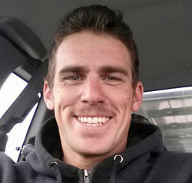
Andrew was born in Orange County, California at Children's Hospital of Orange County on February 15, 1984 to Deborah Pfingston and Tom Ashcraft. His mother will never forget Andrew coming into this world, full of enthusiasm at a whopping 9 lbs. 9 oz. and 21" long. She especially remembers his "absolutely ridiculous insane huge cheeks" that were almost as big as the cheeks on his buttocks, she says with a wistful smile. Andrew grew into his cheeks and became her little cuddle bubble. Deborah had such a close relationship with Andrew all his life that her older son would sometimes get jealous and ask her, "Mom, am I still your special boy?" She assured him that he was.

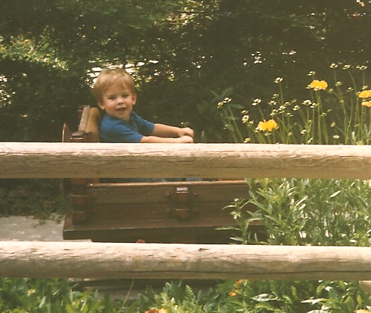
The family eventually moved to Prescott, where Deborah found work as a teacher. While growing up, Andrew attended Abia Judd Elementary School, Mile High Middle School, and graduated from Prescott High School in 2003.

Andrew was successful in everything he did and always enjoyed everything "to the hilt." Whatever Andrew did, he was good at it. He was a talented poet and author. He also had considerable skill drawing pictures. Both he and his brother were excellent skateboarders and skateboarded all over the country. Whenever Andrew faced adversity, it only made him stronger. Once, Andrew shattered his arm skateboarding, the break only made him want to skateboard more. He was such a regular at the emergency room that Deborah practically had the ER on her speed dial.



Even more remarkable was the depth of Andrew's personality. There simply wasn't anyone he couldn't get along with. He could walk into a room with teachers, skateboarders and truck drivers and have equally engaging conversations with each. Andrew also had a passion for music, enjoying a band with which he toured for about one year after graduating high school.

But Andrew always knew he wanted to be a firefighter. Andrew’s mother fondly recalls one day in middle school, the police knocking at her door. The police informed her that Andrew had started a fire at the middle school bus stop. After a stern lecture, Andrew realized that he wanted to become a firefighter. All through high school, he worked toward this goal. Throughout high school and later in life, Andrew always remained modest. Indeed, he would be teased by his fellow Hot Shots for having a trophy from his seventh grade basketball team in his locker. But Deborah knew why: Andrew hit the game-winning shot for his team to go undefeated that season. It wasn't just about Andrew's personal success, but the triumph of his entire team. Andrew was all about teamwork and being a team player, as evidenced by being voted Rookie of the Year by his fellow Hot Shots.

Andrew was always handsome and with his affable personality, was frequently chased by girls. But one eventually caught him.

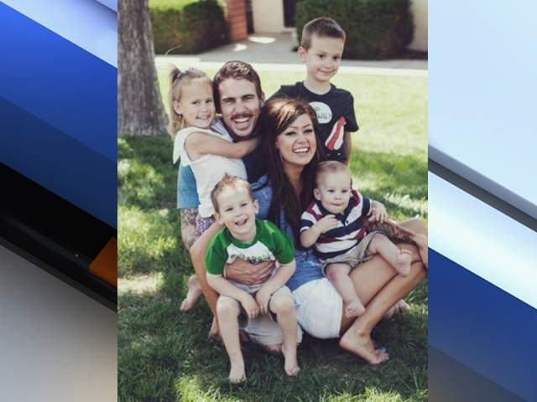
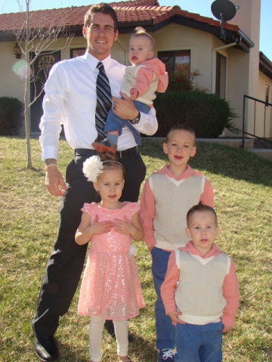
Although Juliann and Andrew had been friends in high school, they didn't date until Andrew came back from his music tour. The two quickly fell in love and found that their romantic relationship based upon a foundation of years of friendship, was a perfect recipe. The two were married on July 22, 2006 the hottest day on record in Prescott. Recalls Deborah, leave it to Andrew to pick the hottest day on record to wear a three-piece black suit.

Juliann and Andrew had four beautiful children, Ryder is currently 6; Shiloh is 4; Tate is 3; and Choice is 1. Choice was born on Andrew's birthday.

Andrew was an excellent father, working to be home as frequently as possible with his children and his wife. He was an active member of the Church of Jesus of latter Day Saints.

The strains of being a firefighter were challenging. During fire season, Andrew had to frequently be away fighting fires. Despite that, he always made every effort to get home as quickly as possible and, more importantly, make the time he spent at home count.

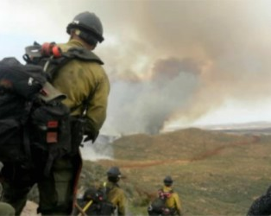
- The Claimants

Juliann Ashcraft & Children

Juliann Ashcraft was born on September 12, 1984 in Prescott, Arizona to James Crockett and Margo Roberts. Juliann is the youngest of seven children and grew up very close to her siblings. Upon graduation from Prescott High School, Juliann attended Yavapai College from 2003 until 2005. Juliann applied and was accepted for an internship at Walt Disney World in 2005. For three years after college, she managed Prescott Downtown Athletic Club. In 2009, Juliann began working as a paralegal until 2013.

Andrew was the light of Juliann’s life. She could not get enough of his love for life, his adorable smile or the sweet way that he loved her. She never got into the car without her husband first opening the door for her. On a daily basis, he told her how much he loved her and how he was the luckiest man in the world. She knew he would never agree, but she felt that she was the lucky one. Andrew often left little notes on Juliann’s car, he would carve their initials into trees and would tell her how beautiful she was while she was cleaning the house or preparing a meal. Andrew would do things for Juliann that she had never seen another man do for his wife. He would color her hair, paint her nails, and he would not only put his clothes in the hamper but he would sort them into separate hampers for colored and whites. Juliann and Andrew would read books together on marriage and God before falling asleep. She has not been able to sleep in the couples’ bed since losing Andrew.
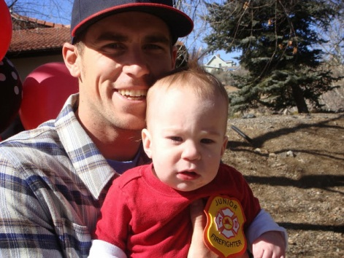
Juliann fell even deeper in love with Andrew when he became a father. He had an amazing and individual relationship with each of his four children.

Juliann gave birth to the couple’s first child, Ryder Sterling, on June 4, 2007. Ryder was the pride of Andrew’s life. He currently attends Taylor Hicks Elementary School. Just like his dad, Ryder loves to ride his bike and skateboard. He plays soccer and t-ball, is an avid artist and is extremely thoughtful and considerate. Andrew took every opportunity he could to teach Ryder the skills he needed in life. He taught him how to ride a bike, swim, swing a bat, kick a ball, taught him how to pray and how to be a gentleman. Andrew always told Ryder to “take care of mommy when daddy was away” and “to be the man of the house.”

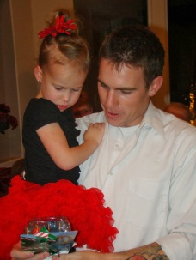
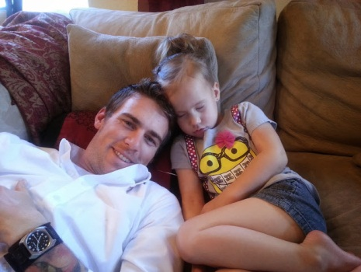
On March 31, 2009, Andrew and Juliann welcomed Shiloh to the family. She currently attends preschool at American Lutheran School. Shiloh loves to perform, sing and dance. As Andrew’s only daughter, she was his baby girl. Since Andrew’s passing, Shiloh has had dreams about her daddy. She dreamt that he came to her in a field of flowers and said, “you will always be my baby girl.” Andrew would often dress up with his daughter and play tea party. There was not a day that passed that Andrew did not tell his baby girl how beautiful she was and how much he loved her.

Tate Andrew was brought into this world on August 22, 2010. Tate is often referred to as “daddy’s mini-me.” He is already a little daredevil and often talks about becoming a firefighter like his dad was. Andrew couldn’t help but smile every time he was around Tate. Andrew nicked named “Tater Tot” and would constantly remark on the resemblance between father and son. Every morning Tate insisted to have his parents draw a mustache on his face so that he could be just like his dad.

The couple experienced a miracle with their youngest, Choice Crockett, who was born on February 15, 2012. At seventeen weeks, Juliann’s water broke and the couple was informed that their child would not survive the pregnancy and they should consider terminating it. Terminating the pregnancy was not an option for the couple. Juliann was hospitalized for the last month of her pregnancy and Andrew assumed the role of a single parent and looked after the three younger children and the house, all while maintaining his full time job and looking after Juliann at the hospital. Due to a medical emergency, Andrew and Juliann spent Valentine’s Day being airvaced to St. Joseph’s hospital in Phoenix. Despite the doctor’s prognosis, and being eight weeks early, Choice was born a healthy baby on his father’s birthday. Andrew cut his son’s umbilical cord, fed him his first bottle and was the first to hold him. It was no surprise that Choice’s first word was “Dada.”

Every Monday night the family would hold Family Home Evening where Andrew and Juliann would teach their children lessons on integrity, love, patience, compassion, leadership, prayer, service and obedience. The family would have lessons, sing songs, read scriptures and pray together. The family also loved to spend time kayaking, hiking Thumb Butte, baking cookies, playing kick ball, wrestling, reading books, riding bikes and swimming.


On the day of the fire, Juliann was sitting on her couch in the living room making videos with the kids to send to Andrew. All off a sudden, Juliann’s phone began ringing off the hook with phone calls and text messages. As she began responding, all of her friends and family wanted to know if Andrew was alright, to which Juliann replied, “Of course he is ok, he is not even home, he is working a fire in Yarnell.” Friends and family began asking Juliann when the last time was she heard from Andrew. She told them around 3:00PM. No one wanted to give her the life shattering news, so they told her to turn on the news. Juliann quickly hung up the phone and turned on the television. Immediately upon turning on the television she saw the headline that would change her, and her children’s, lives forever. She fell to the floor and began screaming, “ NO, NO HE IS DEAD!” The couple’s four children were sitting on the ground in front of Juliann frightened. They children began screaming, “MOMMY? DADDY IS DEAD?” Instantly, Juliann realized not only had her greatest fear become a reality but she had just traumatized her children. A family friend knelt in prayer in her living room with the four children and Juliann ran into her bedroom.

Family members began to arrive one by one to the Ashcraft home. A police car approached the house and two sheriff’s stepped out of the vehicle. As they began to walk up to Juliann, she just sobbed, “NO. NO GOD. PLEASE NO. NOT ANDREW.” The officers confirmed Andrew’s death and Juliann does not recall anything after that moment. Nothing seemed to matter to her anymore. The most vivid memory she has are the expressions of terror on the innocent faces of the couples’ four children who will grow up without their daddy.

Juliann’s life is completely shattered. She says to even call it a “life” is a stretch. Juliann used to wake up next to her husband with the thought, “how can I make Andrew’s day better?” Now, she hates even waking up at all. She has thoughts of her time coming early so that she can be with him again to experience the joy she only received from Andrew. Juliann refuses to give up providing happiness for their children so she tries to compensate for the loss they feel. Assuming the role of two parents while dealing with the grief of her husband’s death is exhausting.


Their oldest son, Ryder, began school this year and was devastated his daddy wasn’t there. The once vibrant young child has become withdrawn and distant. Ryder’s teachers have informed Juliann he often makes comments at school about missing his daddy and how he must be a bad child because his father was taken away from him. There are many days where Shiloh just cries and cries for her father. Every morning she would get dressed and run to her daddy and say “Ta Da,” to which he would always reply “Ohhh la la.” Since the loss of her father she does not say “Ta Da” anymore.

The most heartbreaking for Juliann is watching the two youngest boys. They will only know their father from the stories she tells them. She can envision the beautiful relationships they would have shared. Tate was potty trained prior to losing his father. After the death he has reverted back to complete dependency. In fact, all of the children have reverted back in their own ways and need constant attention. Juliann would give her own life in a heartbeat to bring him back for her children.

Deborah Pfingston

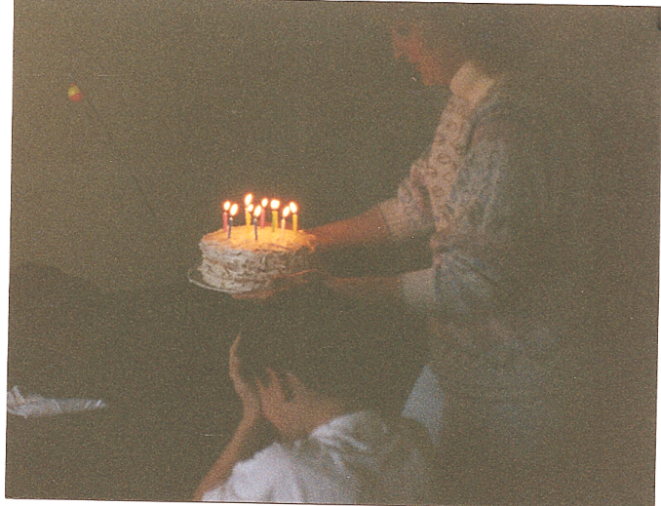
Deborah Pfingston was born outside of Pittsburgh in Westmoreland County, Pennsylvania. She lived outside of Pittsburgh in a quaint community called Harrison City. The town had one thoroughfare, interrupted only by a blinking yellow light. The family lived in a home that her father built throughout her time in Pennsylvania.. However, when Deborah was in high school, the family moved to Orange County, California because her father worked in the restaurant business. Deborah graduated high school in Orange County at Garden Grove High School. When she was about 20, she met Tom and the two dated for a while. The couple eventually had a child, TJ, Andrew's older brother. Right after TJ was born, the couple were married.

Learning of Andrew's death was devastating for Deborah. She knew that Andrew was going on a call, but was always texted by Juliann under their phone tree system that Andrew would be gone. Still, Deborah wasn’t overly concerned because Andrew was always a kid with nine lives (having survived serious falls and other near catastrophes that should have led him to an early grave years earlier). Unfortunately, it was not to be.

All of a sudden on June 30, Deborah started getting tons of text messages. That was unusual for her and she was very surprised. At one point, her friend Brenda called and asked whether Andrew was okay. Deborah inquired as to what was going on and then realized that the texts must have been associated with something bad happening at the fire. By the time she hung up, she had over 42 texts, none of which she was able to read. She was pulling into the church where she planned to call Juliann to find out what was going on. Juliann's father answered the phone and Deborah’s heart sunk. She immediately asked him if Andrew was okay. His response "No." It felt like her heart was literally ripped out of her chest. She could almost hear it ripping. Deborah hung up the phone and simply screamed at the top of her lungs. But it was like watching herself from afar. She was not even aware she was screaming. Meanwhile, her husband Jerry begged her for information about what was going on. Only Deborah begged Jerry to take her to Juliann's because Andrew was hurt. Jerry turned the car around and Deborah called TJ in route. The only words Deborah could get out were, “TJ your brother is dead,” all TJ could muster was a "yes mom, yes."

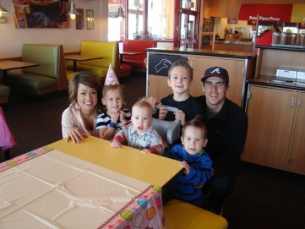
The family went to Prescott Mile High where the community rallied for a prayer vigil. Friends came up and hugged her and offered their condolences.

It was an incredibly surreal experience for Deborah to be sitting on the stage in Andrew's middle school where he had played in the jazz band and hear people tell her that her son was dead.

To this day, Deborah has not been able to move on. She still hears Andrew's voice telling her "yellow." Because he never used the conventional "hello" with her. She still texts Andrew out of habit, telling him to “Be strong, wise, and safe”. She hopes he gets these messages.

Tom Ashcraft

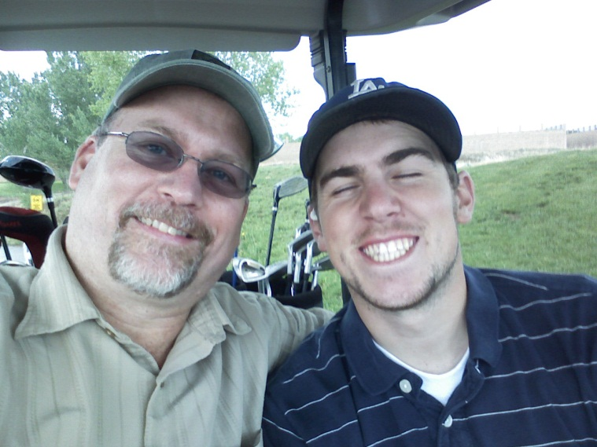
Thomas “Tom” Ashcraft was born in Los Angeles, California to Thomas Ashcraft and Norman Leatherman. Tom obtained his GED from Yavapai College and continued his education for three years after that. Throughout his entire career, Tom has worked in the construction industry. He has worked as a general contractor as well as for general contractors. In more recent years, he has worked for companies providing custom interiors to hotels and casinos.

Becoming a father changed Tom’s life. Tom, Andrew and TJ would do everything together. While living in California, Tom often took the boys to the beach and watch the Anaheim Angels play. They also loved to go camping. Tom had a truck with a camper attached. He would often take the boys on long weekends to Oregon. They would hike all around the surrounding forest, rivers and waterfalls.

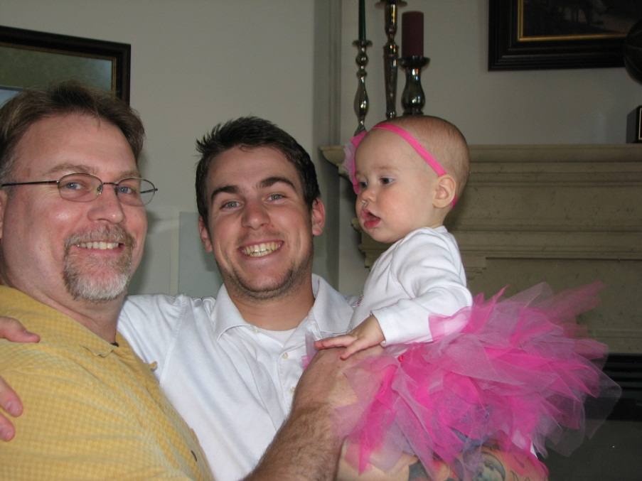
Tom’s relationship with Andrew was always close. Little did Tom realize the Thursday before the fire would be the last day that he would speak to his son. Tom watched the couple’s four children while Andrew and Juliann went to the movies. When they returned Tom told his son he loved him and he would talk to him soon. Tom would not speak to him soon, Tom would never speak to his son again.

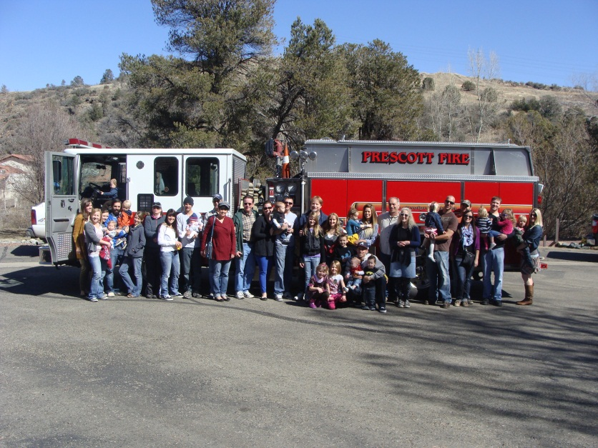
On the day of the fire, Tom was driving through Yarnell on his way to Quartzside, AZ. During his drive he noticed the fire and immediately texted Juliann to see if Andrew had been called to the fire. She told him that Andrew had. Tom pulled over to the side of the road and began taking pictures of the consuming flames. As the afternoon progressed, Tom and Juliann remained in close contact. Tom eventually arrived in Quartzside, he continued to drive toward the Yarnell Hill but was stopped by a Yavapai Co. Sheriff Officer. The officer informed Tom that the Yarnell was being evacuated and traffic was being diverted. At approximately 4:50 Tom again pulled over to the side of the road and gazed at the enormous black tornado of smoke and wondered if his son was alright. Tom got back on the road and continued home to Prescott.

As he was driving he received a call from a friend asking if he had seen the news. Tom had not since he had been travelling. All he was told on the phone was that something had happened to the firefighters in Yarnell. Little did Tom realize that he witnessed the fire that ultimately took his sons life. Tom tried to get ahold of Juliann with no success. He drove directly to her house. Tom was frantic and unsure if his son was injured or even alive. Tom learned the horrific news of his sons passing when the Sheriff’s department arrived at Juliann’s house and informed Tom his son was dead. Tom has suffered immensely and continues to suffer from the loss of his son. His life will never be the same.
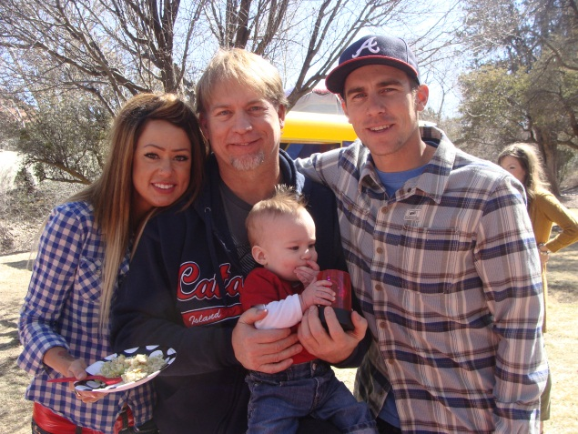

- Sum Certain Demand
As a result of the negligence and gross negligence of the liable public entities, the heirs of Andrew Ashcraft have experienced significant emotional pain and suffering and has lost the love, companionship, care and support of Andrew Ashcraft. In compliance with Arizona law, the heirs of Andrew Ashcraft make a sum certain demand of $50,000,000 Million and 00/100 Dollars as and for the death of Andrew Ashcraft caused by the negligence of the City of Prescott, Yavapai County and State of Arizona.

Under Arizona comparative negligence principles the public entities are free to assign and apportion fault for payment of the settlement sum as they deem fit. To the extent the recipients require formal proposed allocation of this demand, Claimant will settle for the sums certain as follows:

Juliann Ashcraft

- State of Arizona $4,000,000
- County of Yavapai $2,000,000
- Central Yavapai Fire District $2,000,000
- City of Prescott $2,000,000

Total $10,000,000

Ryder Ashcraft

- State of Arizona $3,000,000
- County of Yavapai $1,500,000
- Central Yavapai Fire District $1,500,000
- City of Prescott $1,500,000

Total $7,500,000

Shiloh Ashcraft

- State of Arizona $3,000,000
- County of Yavapai $1,500,000
- Central Yavapai Fire District $1,500,000
- City of Prescott $1,500,000

Total $7,500,000

Tate Ashcraft

- State of Arizona $3,000,000
- County of Yavapai $1,500,000
- Central Yavapai Fire District $1,500,000
- City of Prescott $1,500,000

Total $7,500,000

Choice Ashcraft

- State of Arizona $3,000,000
- County of Yavapai $1,500,000
- Central Yavapai Fire District $1,500,000
- City of Prescott $1,500,000

Total $7,500,000

Tom Ashcraft:

- State of Arizona $2,000,000
- County of Yavapai $1,000,000
- Central Yavapai Fire District $1,000,000
- City of Prescott $1,000,000

Total $5,000,000

/ / /

/ / /

Deborah Pfingston:

- State of Arizona $2,000,000
- County of Yavapai $1,000,000
- Central Yavapai Fire District $1,000,000
- City of Prescott $1,000,000

Total $5,000,000

Claimant invites the recipients to a mediation to explore non-litigated resolution to these claims as well as alternatives to monetary compensation that may assist in resolving these claims.

- Worker’s Compensation Statutes and other Immunities
Immunity from prosecution is not available to the public entities under A.R.S. § 23-1022 because: (1) the negligent actions of the liable public entities were purposefully willful; (2) the City of Prescott did not properly post the workers’ compensation election of benefits rule in the workplace of the Granite Mountain IHC, see A.R.S. §§ 23-906, 23-1022(A); (3) the intergovernmental agreement (IGA) between the City of Prescott and State of Arizona does not comply with the statutory requirements of A.R.S. § 11-952; (4) notice of the IGA was not properly posted as required, see A.R.S. § 23-1022(E); and the immunity from prosecution is not available to defendants Yavapai County, Central Yavapai Fire District nor State of Arizona. Nor are the government entities absolutely or qualifiedly immune from liability since their actions did not involve any fundamental policy decisions and given the grossly negligent manner in which the fire suppression effort was handled. It is the liable parties’ burden to demonstrate the applicability of immunity and this notice in no way forecloses other arguments available to Claimant.

- Arizona Rules of Evidence
Arizona Rules of Evidence, Rule 408 applies to this notice of claim. Nothing in this notice of claim may be used as evidence in any future judicial or administrative proceeding.

- Full Discovery/Investigation
Claimant has not had an opportunity to conduct formal discover to obtain reports, documents, statements, and information from the public entities and public employees involved in the Yarnell Hill fire and its investigations. Claimant reserves the right to supplement and amend this notice of claim should future discovery and/or disclosure determine the existence of additional facts and circumstances surrounding the Yarnell Hill Fire unknown to claimant on the day of filing her notice of claim. This Notice has been Claimant’s good faith effort to comply with the statutory claim requirements. Should the recipients perceive any legal, substantive or procedural deficiencies in this notice, Claimant should be notified immediately so that any such perceived deficiencies can be timely cured without prejudice to the recipients.

- Conclusion
This is a settlement offer. The heirs of Andrew Ashcraft will accept the sums described above (and will participate in good faith mediation to explore alternative compensation models, including non-monetary compensation) to settle all claims resulting from the intentional, willful, reckless, careless and negligent acts of the City of Prescott, Yavapai County, Central Yavapai Fire District and State of Arizona.

Thank you for your prompt attention to this matter. I look forward to your response.

Yours Truly,

THOMAS K. KELLY, P.C.

Thomas K. Kelly
Attorney at Law

ADDITIONAL CLAIMS AGAINST THE CITY OF PRESCOTT ONLY

With respect to the City of Prescott only, Claimant serves notice that, in addition to the wrongful death claims described above, Claimant intends to pursue litigation relating to the City’s wrongful classification of Andrew Ashcraft’s employment status and other conduct for the direct purpose of avoiding additional wage and benefit payments, including contribution to the Public Safety Personnel Retirement System (“PSPRS”). Pursuant to A.R.S. § 12-821.01, the following sets forth information concerning these additional claims.

- Facts upon which the employment claim is based.

Andrew applied for employment with the City as a Granite Mountain Hotshot on November 22, 2010. He requested “full time” employment.

In his employment application, Andrew told the City: “I try to excel in everything that I do in life, I will give 100% every time, and I won’t give up.” He was hired effective February 2011.

Andrew kept his promise to give the job his all, earning “Hotshot Rookie of the Year” honors during his first year of employment.

Andrew was one of eight Hotshots who worked the full year. Despite his exemplary performance, Andrew was laid off for part of one week in February 2013, only to be re-hired. In connection with his re-hire, he was promoted to a supervisory position (Lead Saw” on the Hotshot crew, with an attendant raise in wage from $12.48 per hour to $15.03 per hour. When he was hired, Andrew filled the position of an outgoing “full time” Hotshot.

Although Andrew’s position had been approved by the Prescott City Counsel as a full-time position, the City Manager made the unilateral decision to designate Andrew’s position as “temporary seasonal employee” in order to avoid paying Andrew a higher salary and benefits, including:

- Health insurance;
- Paid sick leave;
- Paid vacation days; and, among other things,
- Enrollment in and contribution to the PSRS.

Instead, the City enrolled Andrew in the Arizona State Retirement System (“ASRS”), the retirement system for government employees who do not regularly endanger themselves as part of their employment duties. The City did not, however, make the required federal social security administration contributions for Andrew. Such contribution is required for employees, unless the employer is contributing to an alternate system such as the PSPRS.

Meanwhile, as a condition of maintaining the Granite Mountain Hotshots’ status with the federal government as an Interregional Hotshot Crew, the City verified that it in fact had eight “full time” positions on the crew. According to City records, there were only six “full time” Hotshots at this time. In other words, the City included Andrew in its classification as a “full time” Hotshot to the federal government, but internally treated Andrew differently for monetary reasons.

Moreover, however his employment status was characterized, the City had a duty under A.R.S. §§ 38-841 to make contributions to the PSPRS. The Legislature established the PRPRS for in order to provide “uniform, consistent and equitable” treatment of government employees “regularly assigned to hazardous duty.” A.R.S. § 38-841(B). The City is an “employer” under the PRPRS and Andrew was an “employee” under the statutes. As a “municipal firefighter” regularly assigned to hazardous duty, Andrew was eligible for PRPRS contributions. A.R.S. § 38-842(24)(b). The PRPRS does not require “full time,” or “non-seasonal” work as a condition of eligibility.

Andrew died on June 30, 2013, at which time his family became damaged by the City’s actions, although these injuries and damages were not discovered until later.

- Liability

The City is liable for failing to appropriately classify Andrew’s employment status. During 2013, Andrew met the City’s own definitional criteria for “full time” employment and, conversely, was employed in a capacity inconsistent with the City’s criteria for “temporary” appointment.

Upon belief, Andrew was laid off in February 2013 and re-hired days later in a shell game effort to allow continued non-payment of fair wages and the full complement of benefits to which he and his family was due. The City is liable for myriad breaches of duties owed to its employees, breach of duties owed under the PSPRS, breach of the implied covenant of good faith and fair dealing in an employment contract and intentional interference with contractual relationships.

Specifically, as outlined above, the City breached its duties to Andrew and his family by not making required contributions to the PSPRS. In addition, by favoring its own coffers to avoid legal and valid contributions to PSPRS, the City breached its implied duty of good faith and fair dealing with its employee and also tortiously interfered with contractual relations by preventing a contract to be formed between Andrew and the PSPRS. Discovery and information revealed at a later time may demonstrate the presence of additional local, state and federal law claims.

- Damages

As a result of the City’s actions, Andrew’s family has lost valuable death benefits available through the PSPRs. Since Andrew died in the line of duty, these benefits include, without limitation:

- A Spouse’s Pension each month for life in the amount of 100% of Andrew’s expected average monthly benefit compensation, less the 20% Child’s Pension; and
- Child’s pension payable in the amount of 20% (allocated in equal shares between Andrew’s four children) as defined by A.R.S. §§ 38-842(23) and 38-846.

In addition, had the City complied with its employer obligations, Andrew would also have been entitled to a tuition waiver for his spouse and children at any Arizona university, refund of contributions from him and his employer of ASRS contributions as well as other ancillary benefits, including health insurance benefits/supplements.

Claimant does not have access to all pertinent government documents relating to contribution formula so as to conduct an expert-intensive evaluation of the total economic impact of the City’s actions on Andrew’s family. For purposes of this demand only, Claimant calculates the loss of income benefit at $3,750,000 and the loss of tuition waiver benefit at $500,000 and the totality of other improperly deprived benefits at $500,000.

- Sum Certain Demand

Claimant will settle all employment-related claims (exclusive of the wrongful death claims described above) against the City for the sum certain of $4,750,000.

- Conclusion

As with the wrongful death claims, Claimant is willing to negotiate a resolution to these claims through private mediation prior to the initiation of litigation.

None of this information should be a surprise to the City, who has already met with Claimant and counsel to discuss these issues. Moreover, all documents relied upon are believed to be in possession of the City. Should the recipient feel information or documents necessary to evaluate the claim are needed, the City is invited to contact counsel immediately who will endeavor to provide any additional information in Claimant’s possession or control.

Tsk/tkk
cc: clients
J. Paladini Prescott City Atty
S. Polk, Yavapai County Atty
file

Although Andrew Ashcraft was employed by the City of Prescott, he was not an employee of Yavapai County, CYFD or the State of Arizona. And, as discussed below, exclusive remedy provisions of the workers’ compensation statutory scheme do not bar this claim. With respect to the ADOSH report’s reference to the Hotshots as state “employees”, Claimant contests that definition and assumption. However, the relevant workplace safety regulations are cited as illustrative of the applicable standard of care the recipients should have complied with in this matter.
The following list is by no means exhaustive or exclusive. New information previously unavailable to the families of lost Hotshot firefighters surfaces on an almost daily basis. Only access to witnesses, investigation documents and other materials traditionally obtained through legal discovery will allow the full extent of the liable parties’ negligence to be revealed. Thus, this claim letter is necessarily based on limited information.
These sums do not include demand for settlement of Claimant’s separate employment related claim against the City of Prescott set forth in the attached addendum.
These figures are subject to periodic cost of living adjustments.

