THOMAS K. KELLY, P.C.
Attorney at Law
_____________________________________________________Thomas K. Kelly
Certified Specialist - Criminal Law AZ Board of Legal Specialization
425 E. Gurley
Prescott, Arizona 86301
Telephone (928) 445-5484
Facsimile (928) 445-0414
tkkelly@kellydefense.com
December 19, 2013

STATE OF ARIZONA ROY HALL
Tom Horne, Arizona Attorney Gen. Incident Commander
Office of the Attorney General Arizona State Forestry Div.
1275 West Washington Street 1110 W. Washington St.
Phoenix, Arizona 85007 Phoenix, Arizona 85007

ARIZONA STATE FORESTRY DIVISION RUSS SHUMATE
Scott Hunt, Arizona State Forester Incident Commander
1110 West Washington Street, Suite 100 Arizona State Forestry Div.
Phoenix, Arizona 85007 1110 W. Washington St.
Phoenix, Arizona 85007
COUNTY OF YAVAPAI
Ana Wayman-Trujillo, Clerk TODD ABEL
Yavapai County Bd. Of Supervisors Central Yavapai Fire District
1015 Fair Street 8555 E. Yavapai Road
Prescott, Arizona 86305 Prescott Valley, Arizona 86314

CITY OF PRESCOTT DARRELL WILLIS
Lynn Mulhall, City Clerk City of Prescott Fire Department
Prescott City Hall 201 S. Cortez Street
City of Prescott Prescott, Arizona 86303
201 S. Cortez Street
Prescott, Arizona 86303

CENTRAL YAVAPAI FIRE DISTRICT
Scott Bliss, Interim Fire Chief
Central Yavapai Fire Department
8555 E. Yavapai Road
Prescott Valley, Arizona 86314

Re: Notice of Claim
Decedent: Travis Carter
Date of Death: June 30, 2013
Claimant: Krista Carter
Brayden Carter, Brielle Carter
Tripp Carter

Dear Public Entities and Employees:

Pursuant to A.R.S. § 12-821.01, this letter serves as a formal Notice of Claim against the City of Prescott, Yavapai County, Central Yavapai Fire District and the State of Arizona (for its agency, the Arizona State Forestry Division) and their employees (collectively, “recipients” or “responsible entities”) for damages incurred by the heirs of Travis Carter, as a result of the their negligence in causing his death on the Yarnell Hill Fire on June 30, 2013. Krista Carter is the spouse of Travis Carter. Brayden Carter (7 yrs) and Brielle Carter (3 yrs) are the biological children of Travis and Krista Carter. Tripp Carter is Travis’ biological father. Glenna Eckel is Travis’ biological mother, but has chosen not to join this claim. These claimants will collectively be referred to in this letter as “Claimant.”

The wrongful death statutory beneficiaries of Travis Carter intend to pursue litigation for Travis ’s wrongful death against the above-named recipients of this claim letter if the following claim is not accepted. This Notice of Claim letter contains a fair and accurate description of the recipient’s intentional, reckless, careless and grossly negligent conduct. The full and complete facts regarding this claim are in the possession of the State of Arizona Division of Forestry, City of Prescott Fire Department, and Yavapai County Fire District and are not available to Claimant. Claimant has relied on facts contained in the Serious Accident Investigation Report dated September 23, 2013, prepared on behalf of the State of Arizona (hereinafter “SAIR Report”), the Arizona Division of Occupational Health and Safety Report released on December 4, 2013 (hereinafter ADOSH Report), and the Arizona State Forestry Division website on a page specifically referenced as “Yarnell Hill Fire Documentation” (hereinafter “Website”), as well as other information gathered through limited investigation.

This Notice of Claim serves as a reasonable foundation for the public entities and employees named above to completely investigate the circumstances of this claim and reach an informed decision regarding whether to settle this claim.

This Notice of Claim letter also contains a fair, reasonable, and firm demand for compensation. Based on the particular facts of this matter and our research regarding wrongful death settlements and awards, the amount demanded for by Travis Carter’s heirs is reasonable and will be accepted if offered by any or all recipients of this Notice of Claim letter.

- Purpose and Statement of Intent
The death of Travis Carter and his 18 fellow Granite Mountain Hotshot Crew members is a tragedy of unimaginable proportions. One of Arizona’s most horrific mass disasters, this catastrophe leaves a devastating wake of sorrow, anguish, frustration, economic ruin and a hole that can never be filled in Claimant’s life.

Claimant seeks compensation from those who caused this travesty, and also non-monetary relief so that history will not repeat itself. Claimant is sensitive and appreciative of the enormous outpouring of financial and emotional support from members of the community and throughout the world. Claimant hopes that changes can be accomplished through this claim process and remains willing to discuss a variety of concepts other than monetary compensation as part of resolution of this claim. Such concepts include:

- adopting necessary policy, procedural and protocol changes in state and local government fire suppression agencies to ensure the safety of firefighters during future wildland fires in Arizona;

- adopting, incorporating, and funding specific safety standards and equipment to enhance the protection of wildland firefighters during future wildland fire suppression efforts in Arizona;

- developing and funding an educational program with its curriculum outlining the environmental and human factors causing the death of the Granite Mountain Hotshot Crew on the Yarnell Hill Fire and further, provide adequate funding for its presentation to current and future wildland firefighters in Arizona on a yearly basis; and

- funding annual scholarships for individuals in need of financial assistance to undergo wildland fire suppression training and education in the name of Claimant’s decedent and his fallen colleagues.

Claimant is aware of the statutory requirement of making a specific sum certain monetary demand for which the claim can be settled. This letter contains such sum certain demands which, if timely tendered, will resolve the case. But it is sincerely hoped that recipients will participate in a global settlement discussion and/or mediation where non-monetary issues can be discussed as alternatives and/or offsets to the financial demands made in this letter.

Claimant believes the most productive way of resolving these claims and bringing peace and closure would be for recipients to engage in pre-suit mediation. Had time allowed, Claimant would have explored this option before serving formal notice of this claim. However, the strictures of Arizona’s statutory scheme for making claims against public entities require this notice be served within 180 days and this letter complies with that mandate. Notwithstanding, Claimant invites the parties to contact Claimant’s counsel and advise if they are willing to participate in pre-suit mediation with decisionmakers capable of making financial and policy decisions.

It is hoped that through this action positive social change can be achieved in connection with global resolution of these claims. Claimant and the other families devastated by this disaster deserve at least that much.

- Summary of Facts
On Friday afternoon, June 28, 2013, a lightning strike caused a small fire on a ridge west of Yarnell, Arizona. Designated the “Yarnell Hill Fire” the responsibility for management of suppression efforts was assigned to the State of Arizona Forestry Division. Given the small size and complexity of the fire, an employee of the State of Arizona, Russ Shumate, a Type 4 Incident Commander was assigned the responsibility of putting out the fire. On Friday, Mr. Shumate made decisions regarding the suppression of the fire from his office in Prescott, Arizona. That afternoon, Mr. Shumate declined an offer from the State of Arizona to send firefighting resources to suppress the fire on Friday night. Shumate, however, ordered a small contingent of firefighters for Saturday morning. Mr. Shumate arrived at the location of the fire Saturday morning, June 29, 2013.

Mr. Shumate’s efforts to control the fire on Saturday failed. Late in the afternoon he ordered a large helicopter and a large air tanker in an effort to control the expanding fire. Due to wind conditions at the aircraft were not able to take off to drop retardant on the Yarnell Hill Fire. At around 5:43 p.m. the State dispatcher offered Shumate the services of a very large air tanker (VLAT) located in Albuquerque, N.M. The VLAT carries 11,200 gallons of retardant – Mr. Shumate declined the offer to use the VLAT and an air drop of retardant was not made on Saturday afternoon. By Saturday evening Shumate lost control of the fire and it grew to about 100 acres. With the fire out of control, Shumate ordered a Type 2 Incident Management Team and additional resources for the next morning.

On June 30 members of the Type 2 Incident Management Team began arriving in Yarnell. The Incident Commander was Roy Hall. Central Yavapai Fire Department Captain, Todd Abel was the Operations Section Chief. Prescott Fire Department Wildland Division Chief, Darrell Willis was assigned the position of Structural Protection Group 2 Supervisor. Also on Sunday morning, the Granite Mountain Interregional Hotshot Crew (“IHC”) and Blue Ridge IHC were deployed to the fire. Granite Mountain IHC is part of the City of Prescott Fire Department, Wildland Fire Division supervised by Chief Darrell Willis. Granite Mountain IHC is the only Type I, Interregional hotshot crew in the United States associated with a Municipal Fire Department. The Blue Ridge IHC is a United States Forest Service Hotshot Crew from Coconino National Forest.

The transition of Incident Management Teams occurred at 10:22 a.m. on Sunday morning. Critical positions in the team, including Safety Officer and Planning Section Chief were not filled at the time of transition. Communication problems existed between all aspects of the suppression efforts on the Yarnell Hill Fire. Throughout the day, as fire behavior increased and conditions became critical, the Incident Command Team became overwhelmed with resulting confusion and fear. As structures in Peeples Valley and Yarnell became threatened, Incident Command failed to place the safety of firefighters as its utmost priority. While moving its Incident Command Post due to erratic and extreme fire behavior, Incident Command failed to notify the Granite Mountain IHC of the impeding danger. The death of Travis Carter and eighteen other members of the Granite Mountain HIS occurred at approximately 4:45 p.m. on June 30, 2013.

- Legal Duties
  - Negligence
    - The Law
Negligence is a breach of the duty of reasonable care that actually and proximately causes injury. Shafer v. Monte Mansfield Motors, 91 Ariz. 331, 333, 372 P.2d 333, 335 (1962). “Duty” refers to the issue of whether the defendant is obligated to take any action to protect the plaintiff. See Markowitz v. Ariz. Parks Bd., 146 Ariz. 352, 355, 706 P.2d 364, 367 (1985). Duty is frequently analyzed in terms of foreseeability. More specifically, “a duty of care . . . extends to potential victims [within] the zone of foreseeable risk.” Rossell v. Volkswagen of Am., 147 Ariz. 160, 164, 709 P.2d 517, 524 (1985).
The duty of care is breached when a defendant fails to act with “reasonable care under the circumstances.” Markowitz, 146 Ariz. at 356, 706 P.2d at 368. Breach is analyzed using an objective standard; courts frequently ask whether a particular defendant behaved in the same way a person of “ordinary prudence” would in the same situation. See Morris v. Ortiz, 103 Ariz. 119, 121, 437 P.2d 652, 654 (1968). In practice, this objective standard involves a “risk/benefit analysis” that weighs the burden of the conduct against the chance and likely severity of any harm to plaintiff. Rossell, 147 Ariz. at 164, 709 P.2d at 521.
Causation has two elements. First, there is the “cause in fact.” Arizona has adopted the “but for” test for cause in fact: “cause in fact exists if the defendant’s act helped cause the final result and if the result would not have happened without the defendant’s act.” Ontiveros v. Borak, 136 Ariz. 500, 505, 667 P.2d 200, 205 (1983). Closely related, Arizona courts also consider whether the defendant’s act was a “substantial factor” in bringing about the plaintiff’s injury. Thompson v. Sun City Community Hosp., Inc., 141 Ariz. 597, 606, 688 P.2d 605, 614 (1984).
Second, there is “proximate cause.” The Arizona Supreme Court has defined proximate cause as “that which, in a natural and continuous sequence, unbroken by any efficient intervening cause, produces an injury, and without which the injury would not have occurred.” McDowell v. Davis, 104 Ariz. 69, 71, 448 P.2d 869, 871 (1968). As a practical matter, proximate cause is “determined upon mixed considerations of logic, common sense, policy and precedent.” Nichols v. Phoenix, 68 Ariz. 124, 136, 202 P.2d 201, 208 (1949). As part of this analysis, great weight is usually placed on the foreseeability of the plaintiff’s injury. Markowitz, 146 Ariz. at 358, 706 P.2d at 370.
Finally, negligence requires damages. See Linthicum v. Nationwide Life Ins. Co., 150 Ariz. 326, 330, 723 P.2d 675, 679 (1986). Damage awards are intended to compensate plaintiffs for losses caused by defendants’ negligent conduct. Damage awards should place the injured person in “as nearly as possible in the condition he would have occupied had the wrong not occurred.” Felder v. U.S., 543 F.2d 657, 667 (9th Cir. 1976).
The government entities will be liable for the acts of their employees under the doctrine of respondeat superior and principles of agency. Under the doctrine of respondeat superior, an employer is vicariously liable for the behavior of an employee when the employee was acting within the course and scope of employment. See Restatement (Second) of Agency § 219. An employee’s conduct is within the course and scope of employment if: (1) it is the kind of conduct the employee is employed to perform; (2) it occurs substantially within the authorized time and space limit of the employment; and (3) it is actuated at least in part by a purpose to serve the employer. See Smith v. Amer. Express Travel Related Servs. Co., 179 Ariz. 131, 135, 876 P.2d 1166, 1170 (App. 1994); Restatement (Second) of Agency § 228.
The government entities will also be liable to the Claimant for negligent hiring, training and supervision of involved personnel. An employer may be liable for harm caused by its employee if it is negligent or reckless in the supervision of the employee. See Kassman v. Busfield Enterprises, Inc., 131 Ariz. 163, 166, 639 P.2d 353, 356 (App. 1981); Restatement (Second) of Agency § 213. An employer may also be liable for its negligence in hiring or retaining an employee. See Duncan v. State, 157 Ariz. 56, 59, 754 P.2d 1160, 1163 (App. 1998); Humana Hosp. v. Superior Court, 154 Ariz. 396, 400, 742 P.2d 1382, 1386 (App. 1987); In re Sproull, 2002 Ariz. Lexis 45 (2002) (negligent retention); Natseway v. Tempe, 184 Ariz. 374, 909 P.2d 441 (App. 1995) (negligent training).
Finally, the public entities’ and their employees’ violation of several statutes, regulations, guidelines and written polices designed to protect the health and safety of persons like Travis Carter constitutes negligence per se. See Brannigan v. Raybuck, 136 Ariz. 513, 517, 667 P.2d 213, 217 (1983); Orlando v. Northcutt, 103 Ariz. 298, 300, 441 P.2d 58, 60 (1968).
    - Analysis
On June 30, 2013, the City of Prescott, Yavapai County, Central Yavapai Fire District and the State of Arizona, their relevant agencies, departments, officials, employees and agents negligently caused the death of Travis Carter during the Yarnell Hill Fire. Travis Carter was a member of the Granite Mountain Interagency Hotshot Crew, a municipal hotshot crew funded, maintained and trained by the City of Prescott. On June 30, 2013, the Granite Mountain Interagency Hotshot Crew was deployed to
suppress a wildfire near the vicinity of Yarnell, Arizona. The lightning fire started and was burning on lands held in trust and managed by the State of Arizona. The Arizona State Forestry Division was responsible for management, control and suppression of the fire, but critical errors by Yavapai County, Central Yavapai Fire District and City of Prescott also played a causative role in causing Travis Carter’s death.

Recipients failed to exercise a standard of care which a reasonably prudent fire suppression agency would exercise in the suppression of a wildfire under conditions similar to those present during the Yarnell Hill Fire. Travis Carter’s death was preventable. Further, with the exercise of reasonable care no member of the Granite Mountain Hotshot Crew would have died on June 30, 2013. Moreover, Travis Carter was not involved in the management or decision making process associated with the suppression of the Yarnell Hill Fire. He was not in charge of any suppression activities of the Granite Mountain Interagency Hotshot crew. Travis Carter’s actions on June 30, 2013, cannot be considered as a contributed cause to his death.

During the Yarnell Hill Fire, the liable public entities and employees failed to adhere to the standard of care adopted by responsible wildland fire suppression agencies throughout the United States. The public entities violated recognized guidelines, policies and procedures approved and adopted for the safe suppression of wildland fires including, but not limited, to: (1) the 10 Standard Firefighting Orders (recognized and adopted by the U.S. Forest Service, Interagency Standards for Fire and Fire Aviation Operations, NFES 2724 (Jan. 2013)); (2) the 18 Watch Out Situations (recognized and adopted by the U.S. Forest Service, Interagency Standards for Fire and Fire Aviation Operations, NFES 2724 (Jan. 2013)); (3) Arizona State Forestry Division – Standard Operational Guideline 701 Fire Suppression and Prescribed Fire Policy, and (4) A.R.S. § 23-403(A)(Employers Duty to Maintain Safe Workplace).

The public entities and employees failure to adhere to the standard of care outlined by these well-established and accepted principles, guidelines and statute negligently caused the death of Travis Carter.

With the limited disclosure available to Claimant described above, the following willful, reckless, negligent and careless acts supporting this claim each contributing to the wrongful death of Travis Carter and other members of the Granite Mountain IHC:

- The state failed to assemble and engage an appropriate initial attack on the small lightning fire creating a situation that later placed hundreds of firefighters at risk and caused the death of the Granite Mountain IHC. On June 28, 2013, the fire could have been easily controlled with minimal, effective suppression efforts. The miscalculation of risk associated with the small lightning fire resulted in a subsequent life threatening event; (ADOSH Report)

- After state’s initial efforts to control the fire failed, it dispatched a skeleton management team to direct firefighting operations. The team lacked sufficient resources to adequately suppress the fire. When it assumed control on June 30, 2013, the state’s “Type 2 Short” Incident Management Team lacked “safety officers” and “division supervisors.” The absence of these required positions contributed to a breakdown in communications during the critical minutes before Travis Carter died; (SAIR Report)
- After the transfer of the fire from the Type 4 Team to the larger Type 2 (Short) Team, the Incident Commanders failed to conduct a Standard Complexity Analysis, an Operational Needs Assessment, or an Incident Action Plan. Moreover, key Safety Officer and Planning Section Chief positions went unfilled and other important officers arrived late for critical planning activities; (ADOSH Report)
- The mental and physical condition of the Granite Mountain IHC was not adequately considered by fire management personnel despite the fact the crew was exhausted, working on its scheduled day off and having already worked 28 days in the month of June, 2013; (ADOSH Report)
- The Incident Commander of the Type 4 team (Russ Shumate) was assigned to the fire on June 28, 2013. It is unclear whether Shumate had “eyes on the fire” as he made critical decisions regarding the initial attack phase of the fire. The IC4 determined the fire was “less than a half-acre in size, 80 percent out, active only in one corner with low spread potential and no structures or people at risk,” and the fire was “inactive, not much of a threat” and that he was “not taking action tonight” Mr. Shumate turned down offers by the state dispatcher to send suppression resources to the fire on Friday. At 7:19 p.m. Shumate also told state dispatch that he was “at [his Prescott] office until further notice.” The Incident Commander’s failed to aggressively initiate suppression efforts during the critical initial attack phase of the fire; (SAIR Report)
- Inadequate and deficient communications contributed to complications causing the death of Travis Carter. “Radio communications were challenging throughout the incident. Some radios were not programed with appropriate tone guards;” (SAIR Report pg. 2)
- Transition of Type 4 through Type 1 incident command teams in fewer than 20 hours added to the confusion and frustration communicating with Granite Mountain IHC, knowing their location at all times, and knowing their location when aircraft on scene were available to drop
retardant to slow the fire immediately before the crew’s fire shelters were deployed. Knowing the location of the Granite Mountain IHC would have saved Travis Carter’s life; (“fire management went through multiple transitions from a Type 4 to a Type 1 incident in fewer than 20 hours”) (“At the time of shelter deployment, a very Large Airtanker was on station over the fire waiting to drop retardant as soon as the crew’s location was determined”) (SAIR Report pgs. 2, 3)

- The transition of incident command teams, communication deficiencies and lack of command’s control or command of the fire lead to a mistaken belief as to the location of the
Granite Mountain IHC during the critical phase of the fire; (“Operations and other resources had concluded the Granite Mountain IHC was located in the black, near the ridge top where they had started that morning. This resulted in confusion about the crew’s actual location at the time of the search and rescue”) (SAIR Report pg. 3)

- The weather information provided to the Granite Mountain IHC was not clearly communicated; (“In retrospect . . . [i]t is possible they may have interpreted the early wind shift as the anticipated wind event.”) (SAIR Report pg. 3)

- Full air attack responsibilities over the Yarnell Hill Fire were deficient contributing to the death of the Granite Mountain IHC; (“The Aerial Supervision Module working the fire was very busy fulfilling leadplane duties, which limited their ability to perform full Air Attack responsibilities over the fire at the same time.”) (SAIR Report pg. 3)

- Shumate (ICT4) had worked 28 days straight as of June 28, 2013. On June 29, 2013, he worked a shift that would last for more than 30 hours. Transition of the fire suppression efforts between Shumate and Roy Hall (ICT2) occurred after Shumate had been awake for more than 24 hours. The Incidence Response Pocket Guide advises that 24 hours without sleep impacts decision making abilities and situational awareness. Mr. Shumate was exhausted at the time of transition impairing his decision making ability and situational awareness impacting the proper transition of the fire to Hall. Other team members failed to notice and correct this condition; (ADOSH Report)

- The Incident Management Team failed to contain the Yarnell Hill Fire before the start of the critical burn period beginning at 10:00 a.m. on Saturday, June 29, 2013; (at 7:40 p.m. on Friday, June 28, 2013, “ICT4 notes the fire is less than a half-acre in size, 80 percent out,
active only in one corner, with low spread potential and no structures or people at risk.”). Russ Shumate decided not to suppress the one-half acre fire during the evening and night of June 28, when temperatures are lower, humidity is higher, and decreased winds, but instead decided to begin suppression efforts the next morning, losing a critical head-start on fire suppression; (SAIR Report pgs. 11 & 12)

- The Incident Management Team failed to contain the Yarnell Hill Fire before the start of the critical burn period beginning at 10:00 a.m. on Sunday, June 30, 2013. On Saturday morning, Shumate requested two single engine airtankers (SEATS). The Wickenburg SEAT Base was not operating and the tankers were located a significant distance from the fire. Each tanker made two drops on the two-acre fire and then were released at 2:42 p.m. - during the critical burn period. Later, Shumate changed his mind and requested the two SEATS and Air Attack return to the fire. Due to availability, only one SEAT and an air attack plane returned to the fire. After the fire jumped its control line on the east flank, Shumate then requested a Type 1 Heavy Helitanker and Large Air Tanker. However, the two aircraft requested were not able to drop on the fire due to wind conditions. Mr. Shumate was then offered a very large air tanker with a capacity of 11,400 gallons of retardant. As the fire suppression efforts were rapidly deteriorating, the ICT4 declined the offer to use the VLAT at 5:50 p.m. At this time, the fire was growing and threatening the town of Yarnell; (SAIR Report pgs. 12 & 13)

- On June 30, 2013, the Incident Management Team identified the Boulder Springs Ranch as “an excellent safety zone.” (SAIR Report pg. 15). The Boulder Springs Ranch was surrounded by unburned fuel, heavy brush and terrain which did not make it an “excellent” safety zone. To exacerbate the misinformation, in order to access the designated safety zone, the Granite Mountain IHC would be required to leave the safety of the black and traverse steep, rocky, difficult terrain in thick, heavy, unburned chaparral fuel. Granite Mountain IHC lacked necessary maps to properly determine the distances between their safety zone in the black and the Boulder Springs Ranch. The Boulder Springs Ranch was not a “bomb proof” or “excellent” safety zone as described and designated by Incident Command; (ADOSH Report)

- The transition between the Type 4, ICT and Type 2, ICT occurred at 10:22 a.m. on June 30, 2013. The transition took place within a short period of time and without the ICT2 and ICT4 conferring for an acceptable length of time. Moreover, the transition occurred at an inappropriate time of day – the beginning of the critical burn period. This transition violated accepted standards of care for the transition of Incident Command Teams resulting in errors, omissions and confusion; (SAIR Report pg. 16).

- The ICT failed to complete a timely Fire Complexity Analysis; (ADOSH Report)

- On June 30, 2013, as weather conditions were changing dramatically, Incident Command (Roy Hall) “chose to evacuate the command post but allowed the Granite Mountain IHC to continue to work downwind of a rapidly progressing wind driven fire;” (ADOSH Report).

- In directing suppression efforts, Mr. Hall identified the protection of “non-defensible structures and pastureland” as a higher priority than the safety of firefighters. At the time, the
Incident Command Team “knew that suppression of extremely active chaparral fuels was ineffective and that wind would push active fire toward non-defensible structures;” (ADOSH Report)

- Due to the failure to promptly remove firefighters from dangers associated with the rapidly spreading fire, the Incident Command Team violated established fire suppression policies causing the death of the Granite Mountain IHC and exposing other firefighters to risk of “smoke inhalation, burns and death;” (ADOSH Report)

- Mr. Hall failed to fill the necessary Safety Officer and Planning Section Chief positions on his Type 2, Incident Command Team resulting in the Granite Mountain IHC not having critical maps readily available during their suppression efforts; (ADOSH Report)

- The failure to fill the Safety Officer position failed to provide the Granite Mountain IHC with information from a safety officer who “would have viewed the fire and fire line assignments from a safety viewpoint;” (ADOSH Report)

- Mr. Hall’s Incident Command Team lacked necessary cohesiveness and consistent communications with suppression personnel on the ground and in the air; (ADOSH Report).

- The Incident Command Team failed to provide the Granite Mountain IHC with a place of employment free from recognized hazards that would cause or would likely cause death or serious physical harm, in that the ICT implemented suppression strategies that prioritized protection of non-defensible structures and pastureland over firefighter safety and failed to prioritize strategies consistent with the Arizona State Forestry Division – Standard Operational Guideline 701 Fire Suppression and Prescribed Fire Policy, when the ICT knew their suppression efforts were ineffective and would push the fire toward the Granite Mountain IHC in violation of A.R.S. § 23-403(A); (ADOSH Report)

- The actions described above, were a “complete failure” of the ICT to protect the Granite Mountain IHC from exposure to smoke, burns and death at a time when the crew was located in a precarious location downwind from the fire; (ADOSH Report)

- The actions of the ICT violated the Arizona State Forestry Division, Standard Operational Guideline 701 by failing to adhere to the basic requirement that “the protection of human life is the single, overriding suppression priority;” (ADOSH Report)

- On June 30, 2013, The ICT knew that fire, wind and fuel conditions transitioned the Yarnell Hill Fire to an “extended attack,” suppression efforts were ineffective, defense of structures was not possible, and the Granite Mountain IHC was working downwind in these most dangerous conditions. “Notwithstanding this knowledge, throughout the afternoon (June 30, 2013), and in disregard of its own requirement to prioritize firefighter safety, fire management failed to re-evaluate, re-prioritize and update suppression efforts and failed to promptly remove [Granite Mountain IHC] working downwind of the fire resulting in multiple … deaths;” (ADOSH Report)

- The Arizona State Forestry Division (ASFD) failed to implement its own extended attack guidelines and procedures including an extended attack safety checklist and wildland fire decision support system with a complexity analysis:

  - ASFD failed to provide a Wildfire Situation Analysis or Wildfire Decision Support System and rationale for selecting a suppression alternative to Incident Management Team 2;

  - ASFD failed to provide Roy Hall (IMT2) with clear written direction in the form of a delegation of authority letter, violating an established standard of care expected by Incident Commanders; and

  - ASFD failed to coordinate aviation resources and ground resources on the same tactical plan; (ADOSH Report)

- The City, County and CYFD joined in the failings above;

- The City, County and CYFD exacerbated the failings described above in that they failed to:

  - Advocate more effective suppression efforts;

  - Bring obvious risks to firefighter safety to the attention of those in command;

  - Notice the fallacy of critical decision making and the exhaustion-impaired state of those responsible for such decision making; and

  - Properly evaluate and assess the training, qualifications, and experience of its firefighters before placing in management/command positions;

- On June 30, 2013, at approximately 1:00 p.m., Raul Marquez, Division Z Supervisor
abandoned his responsibilities associated with directing suppression efforts on Division Z then returned to the command post. Marquez is an employee of the Bureau of Land Management, United States Department of Interior. On the Yarnell Hill Fire Divisions A and Z joined one another. Marquez’s abandonment of his responsibilities left firefighters on Division Z without adequate supervision, support and control. Further, Marquez’s abandonment of his responsibilities adversely affected communications, suppression efforts and the safety of firefighters in the adjoining Division A, including the Granite Mountain IHC; (ADOSH Report) and

- On June 30, 2013, at approximately 3:58 p.m., Air Attack, Rory Collins, left the fire
without explanation turning tactical operations over to “Bravo 33’ who was very busy dealing with lead plane duties. Collins had been communicating with Division A Supervisor and knew the location of the Granite Mountain IHC. This information was not communicated to Bravo 33 when Collins left the fire. Bravo 33 was unaware of both the Division breaks and the location of the Granite Mountain IHC during the critical time period immediately before their entrapment. Given the availability of air resources, knowledge of the location of Granite Mountain IHC would have allowed a retardant drop and saved their lives. (ADOSH Report)

- Damages
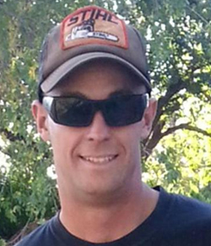
A. The Decedent
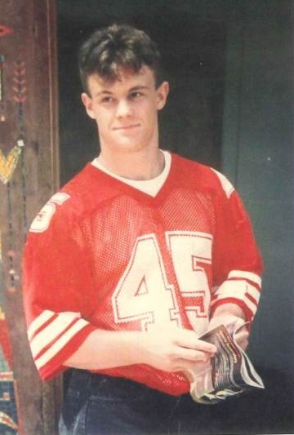
Travis Clay Carter entered this world on August 7, 1981, at Yavapai Community Hospital in Prescott, Arizona, son to Tripp Carter and Glenna Eckel. He was also a son to Chuck Lange and Karl Siegfried and special brother to Melissa Lange. Travis said it was “cool” to have three dads and he loved his little sister.
Travis was a quiet boy growing up who loved spending time with his family – his many grandparents, uncles, aunts and cousins. His friends at a young age were few, but fast and true. He was shy and quiet, but always wanted to help, especially with any outdoor activity. He rode tractors, played in the snow and loved Christmas. One of his favorite places was the fishing pond at the Carter Ranch and at his granny’s house in Paulden, AZ.
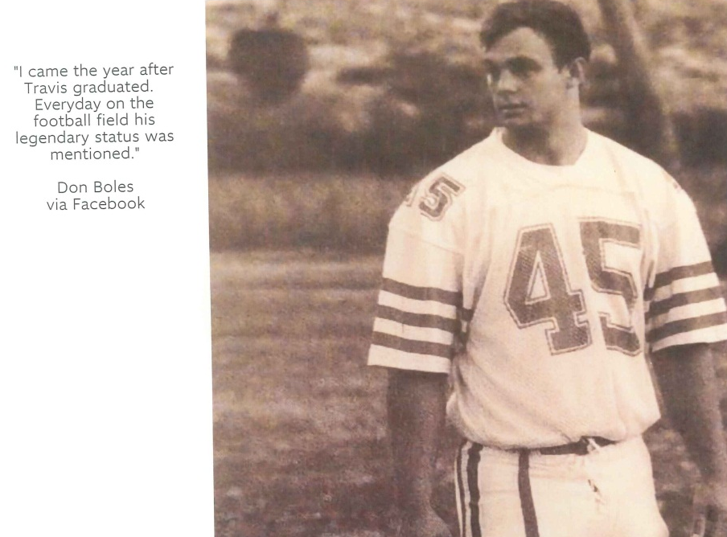
Travis rode horses on the ranch and competed in Gymkhana events starting at the age of four. He loved sports at an early age – Little League, swimming, soccer, football, ice hockey and others. He attended grade schools in Mayer and Flagstaff and graduated with academic and athletic honors from the Orme School in Mayer in 1999. Travis excelled in science, math, art, and athletics. He was an outstanding athlete and currently holds the Arizona state 1A discus record and medaled in shot put, dash and relay events at the state level. He was an all-state, all-conference football player on Orme’s 8-man football team, playing a variety of offensive, defensive and special team positions as #45 for consecutive years. Living as a faculty members son at a boarding school, he developed world-wide friendships with fellow students and faculty who became an extension of his extended family.
Travis received an academic scholarship to the University of Arizona in Tucson and secured a walk-on position with the U of A football team in the fall of 1999. He entered college so he could play football, but injuries forced him off the team by the spring semester. Not really interested in school at this time in his life, he returned home to work on the family ranch until he joined the USFS Prescott Hot Shot Crew in 2001. He loved the physical demands of being a wildland firefighter and the team environment of the Hot Shot crew, so similar to playing football, in terms of physical demand and camaraderie. Travis thrived on the mental and physical challenges of wildland fire fighting and fought numerous local and nationwide fires, including the Rodeo-Chediski. He worked concrete construction with his Uncle Wade and helped his dad and Grandpa Arden on the ranch during the off-season.
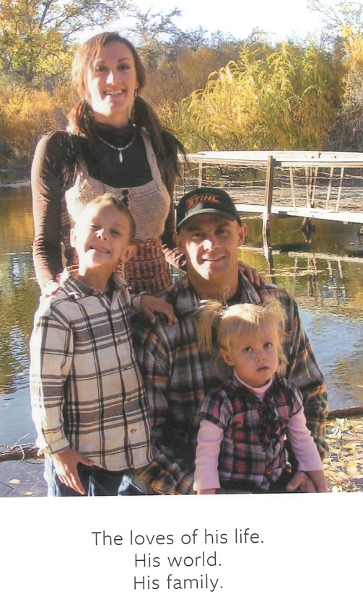
In March of 2005, Travis met Krista Smalley, the woman who would soon become his wife. Some of their favorite activities as a couple included fishing, camping, hiking in Sedona, and working on his dad’s cattle ranch during branding season. In July of 2006, Travis and Krista welcomed their first child into the world, a son by the name of Brayden. When January of 2009 rolled around, Travis decided that he was going to apply for the Type 1 Hot Shot Crew of Prescott, Granite Mountain Interagency Hot Shots. Wildland fire had been one of his passions for many years, and he wanted to return to the field and work with “his brothers” once again. That same season he was selected as Rookie-of-the-Year and later became a full-time member of the crew and Lead Saw Boss. This elite crew was known as Prescott’s “finest.” In the off-season they worked to create “defensible space” around the Prescott Community. In the fall of 2009, he and his wife welcomed their second child, a daughter Brielle.
His family was his whole world, and he loved nothing more than to spend quality time doing the things they loved. As fire season came around every year, it wasn’t easy to get an abundance of family time, but when he did, some of his favorite things to do were fishing, hunting, camping, attending family gatherings, working out at the CrossFit Gym, riding bicycles or ATVs, flying remote control planes, building model rockets and creating Lego models with his son, and “story time” in the evenings with his children.
Travis was a quiet man of incredible physical and inner strength. He was never known to brag, and always helped others to be their best. Travis was a natural leader and mentor and he led by example. His friends and family describe him as unique, loving, dedicated, motivated, gentle, compassionate, respectful, spiritual, a good listener, a man of few, but of important and kind words.
Travis loved kids long before he became a dad. Not surprisingly, he was a perfect son, an awesome brother, a hero dad, a devoted husband, a special friend. Travis managed to juggle the many demands of kids, career, home, friends and extended family without complaint or hesitation. Travis was blessed with teachers, coaches, peers, friends and others who spent time with him and shared their wisdom. The collective teachings of those close to him shaped the man Travis became. He truly was a sum of the whole.
His family and friends are grateful for the gift of his spirit to be with us on this earth. They will not forget the example he set, the lessons he taught, or the many joys he brought to them. They will walk taller, speak softer, listen harder, take care of the children, appreciate all of life and others more every day and fear nothing.

B. The Claimants

Krista Carter & Children

Krista Carter was Travis Carter’s wife. She was born in La Mesa, CA on July 1, 1984 to Steve Smalley and Diana (Smalley) Alexander. Krista’s step father is named John Curtis Alexander. Krista was and only child but has two step siblings.
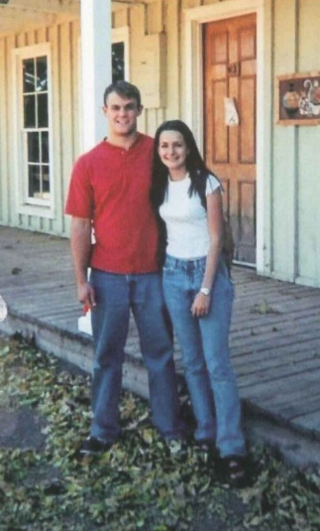
In 2005, Krista met Travis while working at Dillards. Travis walked by her counter and said, “hi.” She admired him to a friend. Then he came back and asked her on a date. Travis called her the next morning to go on a motorcycle ride to Sedona. They were inseparable from that day on.
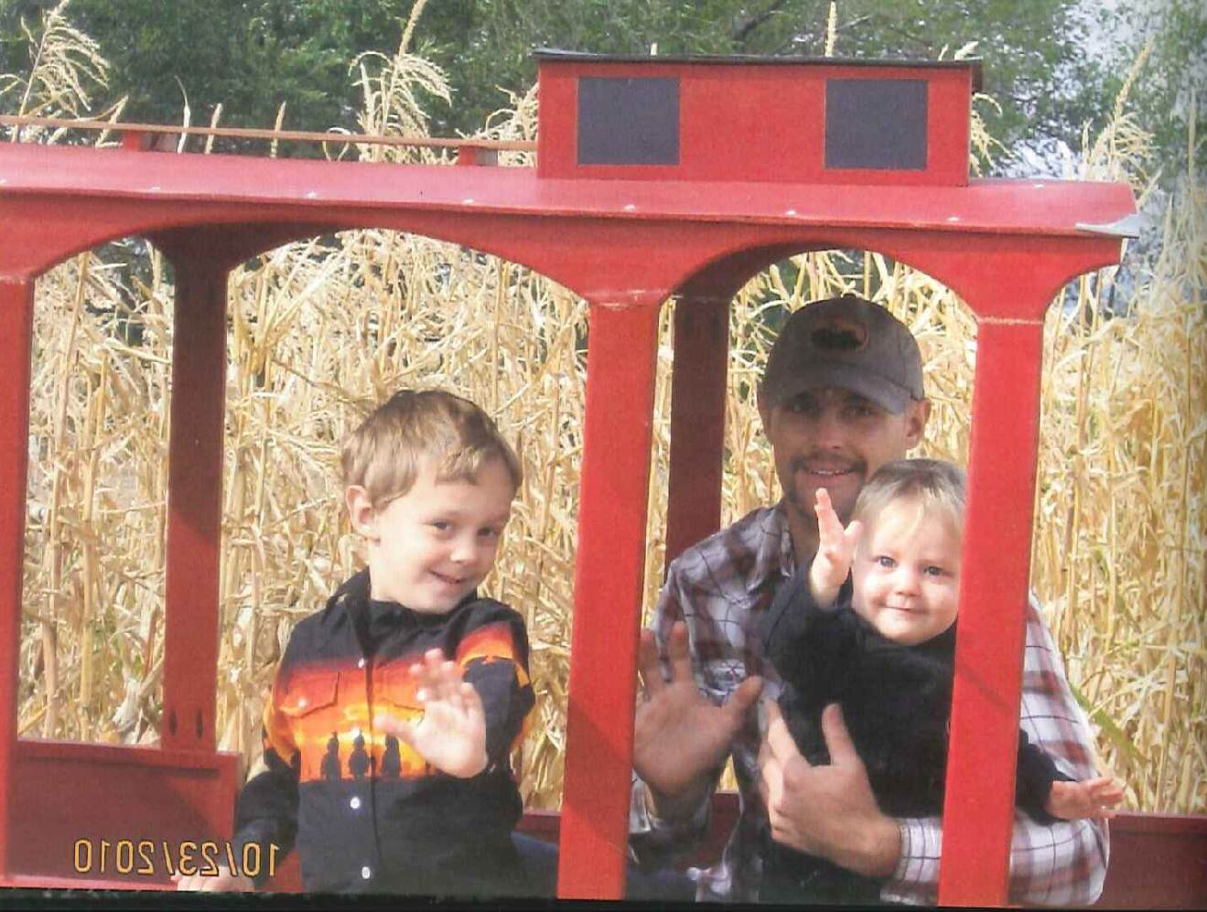
On March 31, 2007 the two married . They welcomed a baby boy into the world in 2007. Travis was working for his uncle at the time doing work in concrete. In 2009, the couple had their second child, Brielle Makenzie Carter. Brielle is a very outgoing people person and would always talk about her daddy.
Krista describes her husband as an awesome man. He was a wonderful husband and father. He always helped her with everything. He listened and supported the family emotionally and financially. He was not a big talker but had a kind soul. He deeply cared about his children. Krista’s father was not around a lot when she was younger since her parents divorced. But it was amazing for Krista to see Travis be an amazing father to her children. She did not have her father around a lot when she was growing up. Her father was a police officer and her parents divorced when she was 14. But Travis‘ world revolved around his children. For instance, he would be around when they were sick and would always tuck the in at night.
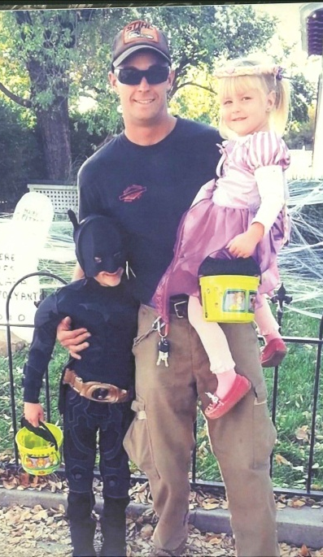
The holidays would be spent at his family’s ranch. At the end of the fire season the family would vacation to Phoenix with the other Hotshot families.
In 2009, Travis started working for the Granite Mountain Hotshots. He worked seasonally and part time in 2009-2010 then became full time in September of 2010. He loved being a part of the team. Krista knew that Travis was disappointed to learn that there was pressure from the city to dismantle the crew.
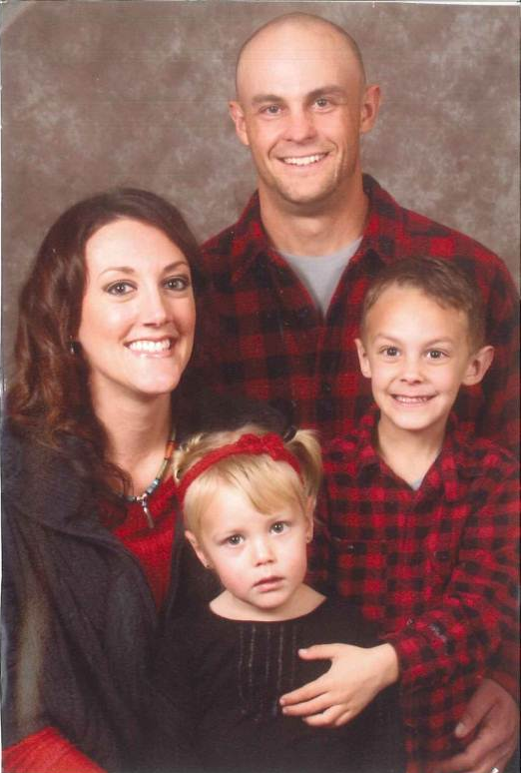
On the last communication, Krista had with her husband he called to wish her a goodnight. He was exhausted from a previous fire and he was about to leave for another fire at 6am. He tried to call her again before he left but Krista could not hear the phone call. She was celebrating her birthday at her mother’s house when she heard the news of the fire. Krista turned on the television then immediately called the station. Then Booner McCarty told her to come to the station.
Krista remembers the memorial service as a nice tribute to Travis. Her worst fears had been actualized. Earlier that year, 2 other firefighters died. One of the firefighters had a wife who was pregnant and it made Krista worry. She and her two children will always remember Travis as an amazing father and husband.

Tripp Carter

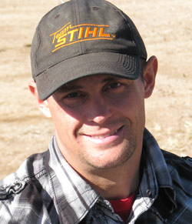
Courtland Arden “Tripp” Carter is the father of Travis Carter. He was born in Prescott, Arizona on April 9, 1943. He has one sister who lives in California. Tripp owns Necktie Ranch and he has been a rancher all is life in Prescott. Tripp married Glenna Eckel in April of 1981 in Prescott. Travis was born later that year in August. Travis had a half-sister named Melissa Lange. Glenna and Tripp were divorced and shared custody of Travis. Travis spent a lot of time on the ranch in Prescott.
Travis could do anything. He could farm, ride horses, and take care of the ranch. He worked with cattle his entire life. Tripp remembered a story about Travis when he was chased down by a steer in a shipping pen and about got hooked. Tripp said this about scared him to death.
His son as an incredible athlete. Travis played lots of football, baseball, and track. After he graduated from prep school he tried out for University of Arizona football, but sustained an injury. Travis came back to the ranch and worked. He also worked for his Uncle Wade’s concrete company.
His hard work and dedication carried over to him becoming a Hotshot fire fighter. Tripp said his son really enjoyed working as a Hotshot. He enjoyed the excitement and brotherhood that came along with the position.
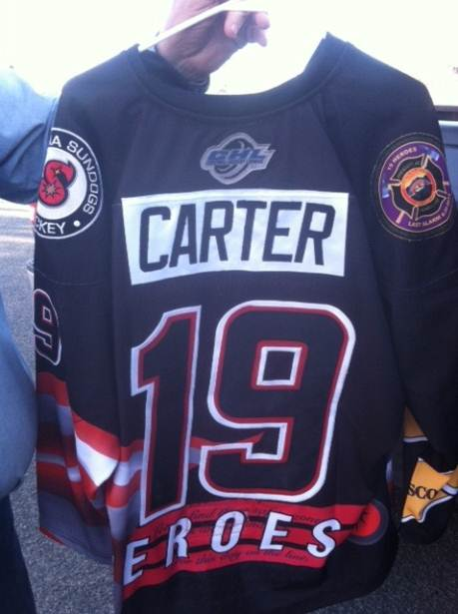
Tripp and Travis had a close relationship. Tripp would go to a lot of Travis’ games. They worked well together. They kept the ranch in order. Travis was very quiet and humble. He never talked about himself. He was always asking about others. Of all the years he knew his son, Travis never said a bad word about anyone.
Tripp first heard of the Yarnell fire on the news. He was unsure if his son was working the fire and called him earlier in the afternoon. He then saw reports of the 19 firefighter being killed. This scared Tripp to death. He was in shock. Around 11 o’clock, a friend called and told Travis had been killed.
Trip misses his son dearly. He loved him very much. Tripp is a very tough man and doesn’t tend to show his emotions. However, the death of his son has been extremely upsetting. Tripp wanted Travis to take over the family ranch at some point. However, this will never happen. He no longer has anyone to carry on the family name. Learning of his son’s death was one of the most painful things he has ever had to experience.
- Sum Certain Demand
As a result of the negligence and gross negligence of the liable public entities, the heirs of Travis Carter have experienced significant emotional pain and suffering and has lost the love, companionship, care and support of Travis Carter. In compliance with Arizona law, the heirs of Travis Carter make a sum certain demand of $30,000,000 Million and 00/100 Dollars as and for the death of Travis Carter caused by the negligence of the City of Prescott, Yavapai County and State of Arizona.

Under Arizona comparative negligence principles the public entities are free to assign and apportion fault for payment of the settlement sum as they deem fit. To the extent the recipients require formal proposed allocation of this demand, Claimant will settle for the sums certain as follows:

Krista Carter

- State of Arizona $4,000,000
- County of Yavapai $2,000,000
- Central Yavapai Fire District $2,000,000
- City of Prescott $2,000,000

Total $10,000,000

Brayden Carter

- State of Arizona $3,000,000
- County of Yavapai $1,500,000
- Central Yavapai Fire District $1,500,000
- City of Prescott $1,500,000

Total $7,500,000

Brielle Carter

- State of Arizona $3,000,000
- County of Yavapai $1,500,000
- Central Yavapai Fire District $1,500,000
- City of Prescott $1,500,000

Total $7,500,000
Tripp Carter:

- State of Arizona $2,000,000
- County of Yavapai $1,000,000
- Central Yavapai Fire District $1,000,000
- City of Prescott $1,000,000

Total $5,000,000

Claimant invites the recipients to mediation to explore non-litigated resolution to these claims as well as alternatives to monetary compensation that may assist in resolving these claims.

- Worker’s Compensation Statutes and other Immunities
Immunity from prosecution is not available to the public entities under A.R.S. § 23-1022 because: (1) the negligent actions of the liable public entities were purposefully willful; (2) the City of Prescott did not properly post the workers’ compensation election of benefits rule in the workplace of the Granite Mountain IHC, see A.R.S. §§ 23-906, 23-1022(A); (3) the intergovernmental agreement (IGA) between the City of Prescott and State of Arizona does not comply with the statutory requirements of A.R.S. § 11-952; (4) notice of the IGA was not properly posted as required, see A.R.S. § 23-1022(E); and the immunity from prosecution is not available to defendants Yavapai County, Central Yavapai Fire District nor State of Arizona. Nor are the government entities absolutely or qualifiedly immune from liability since their actions did not involve any fundamental policy decisions and given the grossly negligent manner in which the fire suppression effort was handled. It is the liable parties’ burden to demonstrate the applicability of immunity and this notice in no way forecloses other arguments available to Claimant.

- Arizona Rules of Evidence
Arizona Rules of Evidence, Rule 408 applies to this notice of claim. Nothing in this notice of claim may be used as evidence in any future judicial or administrative proceeding.

- Full Discovery/Investigation
Claimant has not had an opportunity to conduct formal discover to obtain reports, documents, statements, and information from the public entities and public employees involved in the Yarnell Hill fire and its investigations. Claimant reserves the right to supplement and amend this notice of claim should future discovery and/or disclosure determine the existence of additional facts and circumstances surrounding the Yarnell Hill Fire unknown to claimant on the day of filing her notice of claim. This Notice has been Claimant’s good faith effort to comply with the statutory claim requirements. Should the recipients perceive any legal, substantive or procedural deficiencies in this notice, Claimant should be notified immediately so that any such perceived deficiencies can be timely cured without prejudice to the recipients.

- Conclusion
This is a settlement offer. The heirs of Travis Carter will accept the sums described above (and will participate in good faith mediation to explore alternative compensation models, including non-monetary compensation) to settle all claims resulting from the intentional, willful, reckless, careless and negligent acts of the City of Prescott, Yavapai County, Central Yavapai Fire District and State of Arizona.

Thank you for your prompt attention to this matter. I look forward to your response.

Yours Truly,

THOMAS K. KELLY, P.C.

Thomas K. Kelly
Attorney at Law

Tsk/tkk
cc: clients
J. Paladini Prescott City Atty
S. Polk, Yavapai County Atty
file

Although Travis Carter was employed by the City of Prescott, he was not an employee of Yavapai County, CYFD or the State of Arizona. And, as discussed below, exclusive remedy provisions of the workers’ compensation statutory scheme do not bar this claim. With respect to the ADOSH report’s reference to the Hotshots as state “employees”, Claimant contests that definition and assumption. However, the relevant workplace safety regulations are cited as illustrative of the applicable standard of care the recipients should have complied with in this matter.
The following list is by no means exhaustive or exclusive. New information previously unavailable to the families of lost Hotshot firefighters surfaces on an almost daily basis. Only access to witnesses, investigation documents and other materials traditionally obtained through legal discovery will allow the full extent of the liable parties’ negligence to be revealed. Thus, this claim letter is necessarily based on limited information.

