THOMAS K. KELLY, P.C.
Attorney at Law
_____________________________________________________Thomas K. Kelly
Certified Specialist - Criminal Law AZ Board of Legal Specialization
425 E. Gurley
Prescott, Arizona 86301
Telephone (928) 445-5484
Facsimile (928) 445-0414
tkkelly@kellydefense.com
December 19, 2013

STATE OF ARIZONA ROY HALL
Tom Horne, Arizona Attorney Gen. Incident Commander
Office of the Attorney General . Arizona State Forestry Div.
1275 West Washington Street 1110 W. Washington St.
Phoenix, Arizona 85007 Phoenix, Arizona 85007

ARIZONA STATE FORESTRY DIVISION RUSS SHUMATE
Scott Hunt, Arizona State Forester Incident Commander
1110 West Washington Street, Suite 100 Arizona State Forestry Div.
Phoenix, Arizona 85007 1110 W. Washington St.
Phoenix, Arizona 85007

COUNTY OF YAVAPAI TODD ABEL
Ana Wayman-Trujillo, Clerk Central Yavapai Fire District
Yavapai County Bd. Of Supervisors 8555 E. Yavapai Road
1015 Fair Street Prescott Valley, Arizona 86314
Prescott, Arizona 86305

CITY OF PRESCOTT DARRELL WILLIS
Lynn Mulhall, City Clerk City of Prescott Fire Department
Prescott City Hall 201 S. Cortez Street
City of Prescott Prescott, Arizona 86303
201 S. Cortez Street
Prescott, Arizona 86303

CENTRAL YAVAPAI FIRE DISTRICT
Scott Bliss, Interim Fire Chief
Central Yavapai Fire Department
8555 E. Yavapai Road
Prescott Valley, Arizona 86314

Re: Notice of Claim
Decedent: Christopher MacKenzie
Date of Death: June 30, 2013
Claimant: Michael MacKenzie and Laurie Goralski

Dear Public Entities and Employees:

Pursuant to A.R.S. § 12-821.01, this letter serves as a formal Notice of Claim against the City of Prescott, Yavapai County, Central Yavapai Fire District (“CYFD”) and the State of Arizona (for its agency, the Arizona State Forestry Division) and their employees (collectively, “recipients” or “responsible entities”) for damages incurred by Michael MacKenzie and Laurie Goralski, the heirs of Christopher MacKenzie, as a result of the their negligence in causing his death on the Yarnell Hill Fire on June 30, 2013. Michael and Laurie will collectively be referred to in this letter as “Claimant.”

The wrongful death statutory beneficiaries of Christopher MacKenzie intend to pursue litigation for Chris’wrongful death against the above-named recipients of this claim letter if the following claim is not accepted. This Notice of Claim letter contains a fair and accurate description of the recipient’s intentional, reckless, careless and grossly negligent conduct. The full and complete facts regarding this claim are in the possession of the State of Arizona Division of Forestry, City of Prescott Fire Department, and Yavapai County Fire District and are not available to Claimant. Claimant has relied on facts contained in the Serious Accident Investigation Report dated September 23, 2013, prepared on behalf of the State of Arizona (hereinafter “SAIR Report”), the Arizona Division of Occupational Health and Safety Report released on December 4, 2013 (hereinafter ADOSH Report), and the Arizona State Forestry Division website on a page specifically referenced as “Yarnell Hill Fire Documentation” (hereinafter “Website”), as well as other information gathered through limited investigation.

This Notice of Claim serves as a reasonable foundation for the public entities and employees named above to completely investigate the circumstances of this claim and reach an informed decision regarding whether to settle this claim.

This Notice of Claim letter also contains a fair, reasonable, and firm demand for compensation. Based on the particular facts of this matter and our research regarding wrongful death settlements and awards, the amount demanded for by Christopher MacKenzie’s heirs is reasonable and will be accepted if offered by any or all recipients of this Notice of Claim letter.

- Purpose and Statement of Intent
The death of Christopher MacKenzie and his 18 fellow Granite Mountain Hotshot Crew members is a tragedy of unimaginable proportions. One of Arizona’s most horrific mass disasters, this catastrophe leaves a devastating wake of sorrow, anguish, frustration, economic ruin and a hole that can never be filled in Claimant’s life.

Claimant seeks compensation from those who caused this travesty, and also non-monetary relief so that history will not repeat itself. Claimant is sensitive and appreciative of the enormous outpouring of financial and emotional support from members of the community and throughout the world. Claimant hopes that changes can be accomplished through this claim process and remains willing to discuss a variety of concepts other than monetary compensation as part of resolution of this claim. Such concepts include:

- adopting necessary policy, procedural and protocol changes in state and local government fire suppression agencies to ensure the safety of firefighters during future wildland fires in Arizona;

- adopting, incorporating, and funding specific safety standards and equipment to enhance the protection of wildland firefighters during future wildland fire suppression efforts in Arizona;

- developing and funding an educational program with its curriculum outlining the environmental and human factors causing the death of the Granite Mountain Hotshot Crew on the Yarnell Hill Fire and further, provide adequate funding for its presentation to current and future wildland firefighters in Arizona on a yearly basis; and

- funding annual scholarships for individuals in need of financial assistance to undergo wildland fire suppression training and education in the name of Claimant’s decedent and his fallen colleagues.

Claimant is aware of the statutory requirement of making a specific sum certain monetary demand for which the claim can be settled. This letter contains such sum certain demands which, if timely tendered, will resolve the case. But it is sincerely hoped that recipients will participate in a global settlement discussion and/or mediation where non-monetary issues can be discussed as alternatives and/or offsets to the financial demands made in this letter.

Claimant believes the most productive way of resolving these claims and bringing peace and closure would be for recipients to engage in pre-suit mediation. Had time allowed, Claimant would have explored this option before serving formal notice of this claim. However, the strictures of Arizona’s statutory scheme for making claims against public entities require this notice be served within 180 days and this letter complies with that mandate. Notwithstanding, Claimant invites the parties to contact Claimant’s counsel and advise if they are willing to participate in pre-suit mediation with decisionmakers capable of making financial and policy decisions.

It is hoped that through this action positive social change can be achieved in connection with global resolution of these claims. Claimant and the other families devastated by this disaster deserve at least that much.

- Summary of Facts
On Friday afternoon, June 28, 2013, a lightning strike caused a small fire on a ridge west of Yarnell, Arizona. Designated the “Yarnell Hill Fire” the responsibility for management of suppression efforts was assigned to the State of Arizona Forestry Division. Given the small size and complexity of the fire, an employee of the State of Arizona, Russ Shumate, a Type 4 Incident Commander was assigned the responsibility of putting out the fire. On Friday, Mr. Shumate made decisions regarding the suppression of the fire from his office in Prescott, Arizona. That afternoon, Mr. Shumate declined an offer from the State of Arizona to send firefighting resources to suppress the fire on Friday night. Shumate, however, ordered a small contingent of firefighters for Saturday morning. Mr. Shumate arrived at the location of the fire Saturday morning, June 29, 2013.

Mr. Shumate’s efforts to control the fire on Saturday failed. Late in the afternoon he ordered a large helicopter and a large air tanker in an effort to control the expanding fire. Due to wind conditions at the aircraft were not able to take off to drop retardant on the Yarnell Hill Fire. At around 5:43 p.m. the State dispatcher offered Shumate the services of a very large air tanker (VLAT) located in Albuquerque, N.M. The VLAT carries 11,200 gallons of retardant – Mr. Shumate declined the offer to use the VLAT and an air drop of retardant was not made on Saturday afternoon. By Saturday evening Shumate lost control of the fire and it grew to about 100 acres. With the fire out of control, Shumate ordered a Type 2 Incident Management Team and additional resources for the next morning.

On June 30 members of the Type 2 Incident Management Team began arriving in Yarnell. The Incident Commander was Roy Hall. Central Yavapai Fire Department Captain, Todd Abel was the Operations Section Chief. Prescott Fire Department Wildland Division Chief, Darrell Willis was assigned the position of Structural Protection Group 2 Supervisor. Also on Sunday morning, the Granite Mountain Interregional Hotshot Crew (“IHC”) and Blue Ridge IHC were deployed to the fire. Granite Mountain IHC is part of the City of Prescott Fire Department, Wildland Fire Division supervised by Chief Darrell Willis. Granite Mountain IHC is the only Type I, Interregional hotshot crew in the United States associated with a Municipal Fire Department. The Blue Ridge IHC is a United States Forest Service Hotshot Crew from Coconino National Forest.

The transition of Incident Management Teams occurred at 10:22 a.m. on Sunday morning. Critical positions in the team, including Safety Officer and Planning Section Chief were not filled at the time of transition. Communication problems existed between all aspects of the suppression efforts on the Yarnell Hill Fire. Throughout the day, as fire behavior increased and conditions became critical, the Incident Command Team became overwhelmed with resulting confusion and fear. As structures in Peeples Valley and Yarnell became threatened, Incident Command failed to place the safety of firefighters as its utmost priority. While moving its Incident Command Post due to erratic and extreme fire behavior, Incident Command failed to notify the Granite Mountain IHC of the impeding danger. The death of Christopher MacKenzie and eighteen other members of the Granite Mountain HIS occurred at approximately 4:45 p.m. on June 30, 2013.

- Legal Duties
  - Negligence
    - The Law
Negligence is a breach of the duty of reasonable care that actually and proximately causes injury. Shafer v. Monte Mansfield Motors, 91 Ariz. 331, 333, 372 P.2d 333, 335 (1962). “Duty” refers to the issue of whether the defendant is obligated to take any action to protect the plaintiff. See Markowitz v. Ariz. Parks Bd., 146 Ariz. 352, 355, 706 P.2d 364, 367 (1985). Duty is frequently analyzed in terms of foreseeability. More specifically, “a duty of care . . . extends to potential victims [within] the zone of foreseeable risk.” Rossell v. Volkswagen of Am., 147 Ariz. 160, 164, 709 P.2d 517, 524 (1985).
The duty of care is breached when a defendant fails to act with “reasonable care under the circumstances.” Markowitz, 146 Ariz. at 356, 706 P.2d at 368. Breach is analyzed using an objective standard; courts frequently ask whether a particular defendant behaved in the same way a person of “ordinary prudence” would in the same situation. See Morris v. Ortiz, 103 Ariz. 119, 121, 437 P.2d 652, 654 (1968). In practice, this objective standard involves a “risk/benefit analysis” that weighs the burden of the conduct against the chance and likely severity of any harm to plaintiff. Rossell, 147 Ariz. at 164, 709 P.2d at 521.
Causation has two elements. First, there is the “cause in fact.” Arizona has adopted the “but for” test for cause in fact: “cause in fact exists if the defendant’s act helped cause the final result and if the result would not have happened without the defendant’s act.” Ontiveros v. Borak, 136 Ariz. 500, 505, 667 P.2d 200, 205 (1983). Closely related, Arizona courts also consider whether the defendant’s act was a “substantial factor” in bringing about the plaintiff’s injury. Thompson v. Sun City Community Hosp., Inc., 141 Ariz. 597, 606, 688 P.2d 605, 614 (1984).
Second, there is “proximate cause.” The Arizona Supreme Court has defined proximate cause as “that which, in a natural and continuous sequence, unbroken by any efficient intervening cause, produces an injury, and without which the injury would not have occurred.” McDowell v. Davis, 104 Ariz. 69, 71, 448 P.2d 869, 871 (1968). As a practical matter, proximate cause is “determined upon mixed considerations of logic, common sense, policy and precedent.” Nichols v. Phoenix, 68 Ariz. 124, 136, 202 P.2d 201, 208 (1949). As part of this analysis, great weight is usually placed on the foreseeability of the plaintiff’s injury. Markowitz, 146 Ariz. at 358, 706 P.2d at 370.
Finally, negligence requires damages. See Linthicum v. Nationwide Life Ins. Co., 150 Ariz. 326, 330, 723 P.2d 675, 679 (1986). Damage awards are intended to compensate plaintiffs for losses caused by defendants’ negligent conduct. Damage awards should place the injured person in “as nearly as possible in the condition he would have occupied had the wrong not occurred.” Felder v. U.S., 543 F.2d 657, 667 (9th Cir. 1976).
The government entities will be liable for the acts of their employees under the doctrine of respondeat superior and principles of agency. Under the doctrine of respondeat superior, an employer is vicariously liable for the behavior of an employee when the employee was acting within the course and scope of employment. See Restatement (Second) of Agency § 219. An employee’s conduct is within the course and scope of employment if: (1) it is the kind of conduct the employee is employed to perform; (2) it occurs substantially within the authorized time and space limit of the employment; and (3) it is actuated at least in part by a purpose to serve the employer. See Smith v. Amer. Express Travel Related Servs. Co., 179 Ariz. 131, 135, 876 P.2d 1166, 1170 (App. 1994); Restatement (Second) of Agency § 228.
The government entities will also be liable to the Claimant for negligent hiring, training and supervision of involved personnel. An employer may be liable for harm caused by its employee if it is negligent or reckless in the supervision of the employee. See Kassman v. Busfield Enterprises, Inc., 131 Ariz. 163, 166, 639 P.2d 353, 356 (App. 1981); Restatement (Second) of Agency § 213. An employer may also be liable for its negligence in hiring or retaining an employee. See Duncan v. State, 157 Ariz. 56, 59, 754 P.2d 1160, 1163 (App. 1998); Humana Hosp. v. Superior Court, 154 Ariz. 396, 400, 742 P.2d 1382, 1386 (App. 1987); In re Sproull, 2002 Ariz. Lexis 45 (2002) (negligent retention); Natseway v. Tempe, 184 Ariz. 374, 909 P.2d 441 (App. 1995) (negligent training).
Finally, the public entities’ and their employees’ violation of several statutes, regulations, guidelines and written polices designed to protect the health and safety of persons like Christopher MacKenzie constitutes negligence per se. See Brannigan v. Raybuck, 136 Ariz. 513, 517, 667 P.2d 213, 217 (1983); Orlando v. Northcutt, 103 Ariz. 298, 300, 441 P.2d 58, 60 (1968).
    - Analysis
On June 30, 2013, the City of Prescott, Yavapai County, Central Yavapai Fire District and the State of Arizona, their relevant agencies, departments, officials, employees and agents negligently caused the death of Christopher MacKenzie during the Yarnell Hill Fire. Christopher MacKenzie was a member of the Granite
Mountain Interagency Hotshot Crew, a municipal hotshot crew funded, maintained and trained by the City of Prescott. On June 30, 2013, the Granite Mountain Interagency Hotshot Crew was deployed to
suppress a wildfire near the vicinity of Yarnell, Arizona. The lightning fire started and was burning on lands held in trust and managed by the State of Arizona. The Arizona State Forestry Division was responsible for management, control and suppression of the fire, but critical errors by Yavapai County, Central Yavapai Fire District and City of Prescott also played a causative role in causing Christopher MacKenzie’s death.

Recipients failed to exercise a standard of care which a reasonably prudent fire suppression agency would exercise in the suppression of a wildfire under conditions similar to those present during the Yarnell Hill Fire. Christopher MacKenzie’s death was preventable. Further, with the exercise of reasonable care no member of the Granite Mountain Hotshot Crew would have died on June 30, 2013. Moreover, Christopher MacKenzie was not involved in the management or decision making process associated with the suppression of the Yarnell Hill Fire. He was not in charge of any suppression activities of the Granite Mountain Interagency Hotshot crew. Christopher MacKenzie’s actions on June 30, 2013, cannot be considered as a contributed cause to his death.

During the Yarnell Hill Fire, the liable public entities and employees failed to adhere to the standard of care adopted by responsible wildland fire suppression agencies throughout the United States. The public entities violated recognized guidelines, policies and procedures approved and adopted for the safe suppression of wildland fires including, but not limited, to: (1) the 10 Standard Firefighting Orders (recognized and adopted by the U.S. Forest Service, Interagency Standards for Fire and Fire Aviation Operations, NFES 2724 (Jan. 2013)); (2) the 18 Watch Out Situations (recognized and adopted by the U.S. Forest Service, Interagency Standards for Fire and Fire Aviation Operations, NFES 2724 (Jan. 2013)); (3) Arizona State Forestry Division – Standard Operational Guideline 701 Fire Suppression and Prescribed Fire Policy, and (4) A.R.S. § 23-403(A)(Employers Duty to Maintain Safe Workplace).

The public entities’ and employees’ failure to adhere to the standard of care outlined by these well-established and accepted principles, guidelines and statute negligently caused the death of Christopher MacKenzie.

With the limited disclosure available to Claimant described above, the following willful, reckless, negligent and careless acts supporting this claim each contributing to the wrongful death of Christopher MacKenzie and other members of the Granite Mountain IHC:

- The state failed to assemble and engage an appropriate initial attack on the small lightning fire creating a situation that later placed hundreds of firefighters at risk and caused the death of the Granite Mountain IHC. On June 28, 2013, the fire could have been easily controlled with minimal, effective suppression efforts. The miscalculation of risk associated with the small lightning fire resulted in a subsequent life threatening event; (ADOSH Report)

- After state’s initial efforts to control the fire failed, it dispatched a skeleton management team to direct firefighting operations. The team lacked sufficient resources to adequately suppress the fire. When it assumed control on June 30, 2013, the state’s “Type 2 Short” Incident Management Team lacked “safety officers” and “division supervisors.” The absence of these required positions contributed to a breakdown in communications during the critical minutes before Christopher MacKenzie died; (SAIR Report)
- After the transfer of the fire from the Type 4 Team to the larger Type 2 (Short) Team, the Incident Commanders failed to conduct a Standard Complexity Analysis, an Operational Needs Assessment, or an Incident Action Plan. Moreover, key Safety Officer and Planning Section Chief positions went unfilled and other important officers arrived late for critical planning activities; (ADOSH Report)
- The mental and physical condition of the Granite Mountain IHC was not adequately considered by fire management personnel despite the fact the crew was exhausted, working on its scheduled day off and having already worked 28 days in the month of June, 2013; (ADOSH Report)
- The Incident Commander of the Type 4 team (Russ Shumate) was assigned to the fire on June 28, 2013. It is unclear whether Shumate had “eyes on the fire” as he made critical decisions regarding the initial attack phase of the fire. The IC4 determined the fire was “less than a half-acre in size, 80 percent out, active only in one corner with low spread potential and no structures or people at risk,” and the fire was “inactive, not much of a threat” and that he was “not taking action tonight” Mr. Shumate turned down offers by the state dispatcher to send suppression resources to the fire on Friday. At 7:19 p.m. Shumate also told state dispatch that he was “at [his Prescott] office until further notice.” The Incident Commander’s failed to aggressively initiate suppression efforts during the critical initial attack phase of the fire; (SAIR Report)
- Inadequate and deficient communications contributed to complications causing the death of Christopher MacKenzie. “Radio communications were challenging throughout the incident. Some radios were not programed with appropriate tone guards;” (SAIR Report pg. 2)
- Transition of Type 4 through Type 1 incident command teams in fewer than 20 hours added to the confusion and frustration communicating with Granite Mountain IHC, knowing their location at all times, and knowing their location when aircraft on scene were available to drop
retardant to slow the fire immediately before the crew’s fire shelters were deployed. Knowing the location of the Granite Mountain IHC would have saved Christopher MacKenzie’s life; (“fire management went through multiple transitions from a Type 4 to a Type 1 incident in fewer than 20 hours”) (“At the time of shelter deployment, a very Large Airtanker was on station over the fire waiting to drop retardant as soon as the crew’s location was determined”) (SAIR Report pgs. 2, 3)

- The transition of incident command teams, communication deficiencies and lack of command’s control or command of the fire lead to a mistaken belief as to the location of the
Granite Mountain IHC during the critical phase of the fire; (“Operations and other resources had concluded the Granite Mountain IHC was located in the black, near the ridge top where they had started that morning. This resulted in confusion about the crew’s actual location at the time of the search and rescue”) (SAIR Report pg. 3)

- The weather information provided to the Granite Mountain IHC was not clearly communicated; (“In retrospect . . . [i]t is possible they may have interpreted the early wind shift as the anticipated wind event.”) (SAIR Report pg. 3)

- Full air attack responsibilities over the Yarnell Hill Fire were deficient contributing to the death of the Granite Mountain IHC; (“The Aerial Supervision Module working the fire was very busy fulfilling leadplane duties, which limited their ability to perform full Air Attack responsibilities over the fire at the same time.”) (SAIR Report pg. 3)

- Shumate (ICT4) had worked 28 days straight as of June 28, 2013. On June 29, 2013, he worked a shift that would last for more than 30 hours. Transition of the fire suppression efforts between Shumate and Roy Hall (ICT2) occurred after Shumate had been awake for more than 24 hours. The Incidence Response Pocket Guide advises that 24 hours without sleep impacts decision making abilities and situational awareness. Mr. Shumate was exhausted at the time of transition impairing his decision making ability and situational awareness impacting the proper transition of the fire to Hall. Other team members failed to notice and correct this condition; (ADOSH Report)

- The Incident Management Team failed to contain the Yarnell Hill Fire before the start of the critical burn period beginning at 10:00 a.m. on Saturday, June 29, 2013; (at 7:40 p.m. on Friday, June 28, 2013, “ICT4 notes the fire is less than a half-acre in size, 80 percent out,
active only in one corner, with low spread potential and no structures or people at risk.”). Russ Shumate decided not to suppress the one-half acre fire during the evening and night of June 28, when temperatures are lower, humidity is higher, and decreased winds, but instead decided to begin suppression efforts the next morning, losing a critical head-start on fire suppression; (SAIR Report pgs. 11 & 12)

- The Incident Management Team failed to contain the Yarnell Hill Fire before the start of the critical burn period beginning at 10:00 a.m. on Sunday, June 30, 2013. On Saturday morning, Shumate requested two single engine airtankers (SEATS). The Wickenburg SEAT Base was not operating and the tankers were located a significant distance from the fire. Each tanker made two drops on the two-acre fire and then were released at 2:42 p.m. - during the critical burn period. Later, Shumate changed his mind and requested the two SEATS and Air Attack return to the fire. Due to availability, only one SEAT and an air attack plane returned to the fire. After the fire jumped its control line on the east flank, Shumate then requested a Type 1 Heavy Helitanker and Large Air Tanker. However, the two aircraft requested were not able to drop on the fire due to wind conditions. Mr. Shumate was then offered a very large air tanker with a capacity of 11,400 gallons of retardant. As the fire suppression efforts were rapidly deteriorating, the ICT4 declined the offer to use the VLAT at 5:50 p.m. At this time, the fire was growing and threatening the town of Yarnell; (SAIR Report pgs. 12 & 13)

- On June 30, 2013, the Incident Management Team identified the Boulder Springs Ranch as “an excellent safety zone.” (SAIR Report pg. 15). The Boulder Springs Ranch was surrounded by unburned fuel, heavy brush and terrain which did not make it an “excellent” safety zone. To exacerbate the misinformation, in order to access the designated safety zone, the Granite Mountain IHC would be required to leave the safety of the black and traverse steep, rocky, difficult terrain in thick, heavy, unburned chaparral fuel. Granite Mountain IHC lacked necessary maps to properly determine the distances between their safety zone in the black and the Boulder Springs Ranch. The Boulder Springs Ranch was not a “bomb proof” or “excellent” safety zone as described and designated by Incident Command; (ADOSH Report)

- The transition between the Type 4, ICT and Type 2, ICT occurred at 10:22 a.m. on June 30, 2013. The transition took place within a short period of time and without the ICT2 and ICT4 conferring for an acceptable length of time. Moreover, the transition occurred at an inappropriate time of day – the beginning of the critical burn period. This transition violated accepted standards of care for the transition of Incident Command Teams resulting in errors, omissions and confusion; (SAIR Report pg. 16).

- The ICT failed to complete a timely Fire Complexity Analysis; (ADOSH Report)

- On June 30, 2013, as weather conditions were changing dramatically, Incident Command (Roy Hall) “chose to evacuate the command post but allowed the Granite Mountain IHC to continue to work downwind of a rapidly progressing wind driven fire;” (ADOSH Report).

- In directing suppression efforts, Mr. Hall identified the protection of “non-defensible structures and pastureland” as a higher priority than the safety of firefighters. At the time, the
Incident Command Team “knew that suppression of extremely active chaparral fuels was ineffective and that wind would push active fire toward non-defensible structures;” (ADOSH Report)

- Due to the failure to promptly remove firefighters from dangers associated with the rapidly spreading fire, the Incident Command Team violated established fire suppression policies causing the death of the Granite Mountain IHC and exposing other firefighters to risk of “smoke inhalation, burns and death;” (ADOSH Report)

- Mr. Hall failed to fill the necessary Safety Officer and Planning Section Chief positions on his Type 2, Incident Command Team resulting in the Granite Mountain IHC not having critical maps readily available during their suppression efforts; (ADOSH Report)

- The failure to fill the Safety Officer position failed to provide the Granite Mountain IHC with information from a safety officer who “would have viewed the fire and fire line assignments from a safety viewpoint;” (ADOSH Report)

- Mr. Hall’s Incident Command Team lacked necessary cohesiveness and consistent communications with suppression personnel on the ground and in the air; (ADOSH Report).

- The Incident Command Team failed to provide the Granite Mountain IHC with a place of employment free from recognized hazards that would cause or would likely cause death or serious physical harm, in that the ICT implemented suppression strategies that prioritized protection of non-defensible structures and pastureland over firefighter safety and failed to prioritize strategies consistent with the Arizona State Forestry Division – Standard Operational Guideline 701 Fire Suppression and Prescribed Fire Policy, when the ICT knew their suppression efforts were ineffective and would push the fire toward the Granite Mountain IHC in violation of A.R.S. § 23-403(A); (ADOSH Report)

- The actions described above, were a “complete failure” of the ICT to protect the Granite Mountain IHC from exposure to smoke, burns and death at a time when the crew was located in a precarious location downwind from the fire; (ADOSH Report)

- The actions of the ICT violated the Arizona State Forestry Division, Standard Operational Guideline 701 by failing to adhere to the basic requirement that “the protection of human life is the single, overriding suppression priority;” (ADOSH Report)

- On June 30, 2013, The ICT knew that fire, wind and fuel conditions transitioned the Yarnell Hill Fire to an “extended attack,” suppression efforts were ineffective, defense of structures was not possible, and the Granite Mountain IHC was working downwind in these most dangerous conditions. “Notwithstanding this knowledge, throughout the afternoon (June 30, 2013), and in disregard of its own requirement to prioritize firefighter safety, fire management failed to re-evaluate, re-prioritize and update suppression efforts and failed to promptly remove [Granite Mountain IHC] working downwind of the fire resulting in multiple … deaths;” (ADOSH Report)

- The Arizona State Forestry Division (ASFD) failed to implement its own extended attack guidelines and procedures including an extended attack safety checklist and wildland fire decision support system with a complexity analysis:

  - ASFD failed to provide a Wildfire Situation Analysis or Wildfire Decision Support System and rationale for selecting a suppression alternative to Incident Management Team 2;

  - ASFD failed to provide Roy Hall (IMT2) with clear written direction in the form of a delegation of authority letter, violating an established standard of care expected by Incident Commanders; and

  - ASFD failed to coordinate aviation resources and ground resources on the same tactical plan; (ADOSH Report)

- The City, County and CYFD joined in the failings above;

- The City, County and CYFD exacerbated the failings described above in that they failed to:

  - advocate more effective suppression efforts;

  - bring obvious risks to firefighter safety to the attention of those in command;

  - notice the fallacy of critical decision making and the exhaustion-impaired state of those responsible for such decision making; and

  - Properly evaluate and assess the training, qualifications, and experience of its firefighters before placing in management/command positions;

- On June 30, 2013, at approximately 1:00 p.m., Raul Marquez, Division Z Supervisor
abandoned his responsibilities associated with directing suppression efforts on Division Z then returned to the command post. Marquez is an employee of the Bureau of Land Management, United States Department of Interior. On the Yarnell Hill Fire Divisions A and Z joined one another. Marquez’s abandonment of his responsibilities left firefighters on Division Z without adequate supervision, support and control. Further, Marquez’s abandonment of his responsibilities adversely affected communications, suppression efforts and the safety of firefighters in the adjoining Division A, including the Granite Mountain IHC; (ADOSH Report) and

- On June 30, 2013, at approximately 3:58 p.m., Air Attack, Rory Collins, left the fire
without explanation turning tactical operations over to “Bravo 33’ who was very busy dealing with lead plane duties. Collins had been communicating with Division A Supervisor and knew the location of the Granite Mountain IHC. This information was not communicated to Bravo 33 when Collins left the fire. Bravo 33 was unaware of both the Division breaks and the location of the Granite Mountain IHC during the critical time period immediately before their entrapment. Given the availability of air resources, knowledge of the location of Granite Mountain IHC would have allowed a retardant drop and saved their lives. (ADOSH Report)

- Damages
- The Decedent


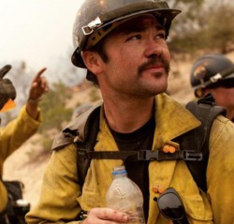
Christopher MacKenzie was born at Kaiser Hospital in Fontana, California on September 12, 1982. He was born with eye lashes that women would die for and before he left the hospital one of the maternity ward nurses put him in one arm and a set of twin boys on the other and showed them off to all the mothers and nurses. He was taken home to San Bernardino to meet his 17-month-old brother Aaron. From the very beginning you could tell he was going to be mellow and easy going.

When he was three his family moved to Hemet and he attended elementary, middle and high school. He was in the GATE program for exceptional students when in elementary school and he was a Boy Scout. He was a big kid, and upon graduating from middle school went out for football at Hemet High and played all four years. Because of football he developed a love for working out and was well on his way to becoming healthy by the time he graduated in 2001.

After high school he developed a passion for snowboarding, moved to Big Bear, went to work for Snow Summit for four seasons, and became an excellent snow boarder. After spending time on a fuels crew with the Bureau of Land Management, Chris applied to become a seasonal firefighter with the U.S. Forest service and ended up on the Taquitz crew on the San Bernardino National Forest. Fighting fires was in Christopher’s blood. His father, Michael MacKenzie was a former firefighter for Cal Fire near Riverside, California. But being a firefighter was more to Christopher than just finding excitement. He loved helping people. He loved being there for the community when they called in need.

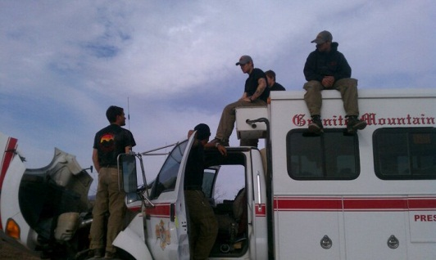
He went on to serve on a helicopter crew for the Bureau of Land Management and the Mill Creek Hotshots on the San Bernardino National Forest. He was invited to apply to the Granite Mountain Hotshots by Aaron Lawson, one of his former captains and just started his third season as a full time employee of Prescott City Fire as a lead crew member.

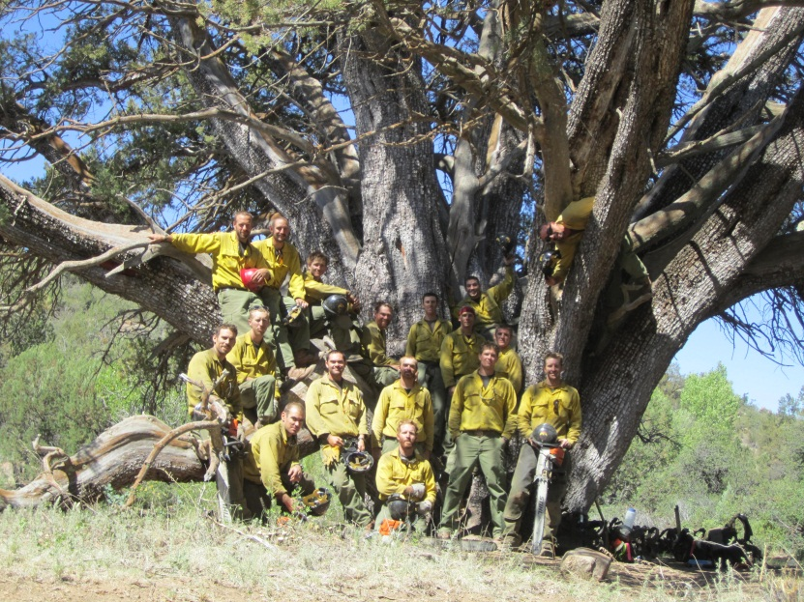
Chris lived his life to the fullest. He visited destinations most people only dreamed about. He craved adventure and excitement. He collected friendships like other people collect shot glasses. He loved fighting wildfire and told his brother he saw it as a way to see the most beautiful country in America. He was loved by everyone he met and will forever have a place in their hearts. A childhood friend described Christopher as one of the greatest human beings that ever lived. Christopher is survived by his mother Lauri Goralski, father Michael Mackenzie, brother Aaron Mackenzie, step mother Janice Mackenzie, and step sisters Janae Gier and Jill Allison.

- The Claimants

Michael MacKenzie

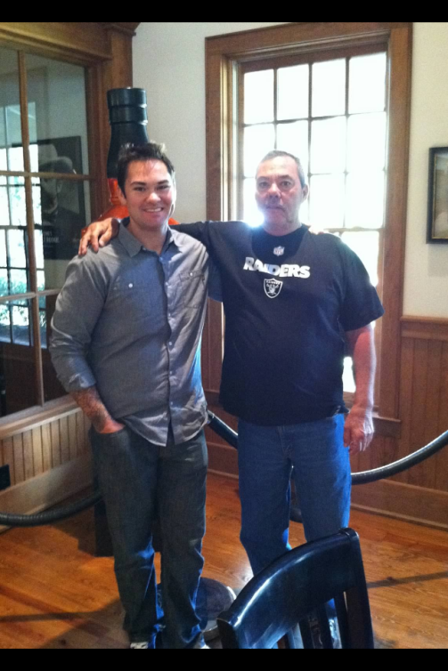
Michael MacKenzie was born in 1950 in Hong Kong, China. His mother was born in Shanghai, China and immigrated to California with her five children. Michael grew up in Southern California. He met his wife Laurie in junior college. They lived together, and then moved to Northern California where they got married. They had two children Aaron and Christopher. Aaron is the oldest. Aaron and Christopher were very close. Only a year apart, they grew up going to school together. However, their personalities were polar opposites. Aaron is very quiet and reserved, but Christopher was very outgoing and personable.

When Christopher was around his dad he was always a compassionate and giving young man. He cared about his family and friends. He was very friendly and always smiling. His father remembered Christopher had many girlfriends throughout the years. His positive attitude and compassionate personality were addictive. People were drawn to Christopher. It was difficult for people to not like him. Michael remarried after he divorced Laurie. Christopher respected his step-mother Janice and her two daughters. Christopher got along great with his half-sisters. That was just his personality. He didn’t hold grudges. He was truly a nice human being to his core.

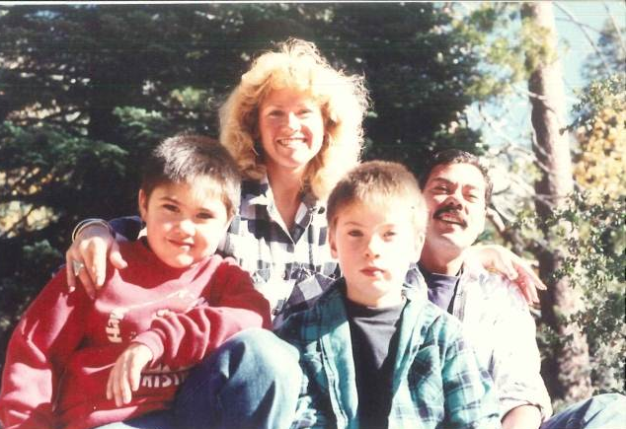
Christopher was always sensitive. Christopher wrote poetry before he died. His father became choked up as he tried to read aloud one of Christopher’s poems. His poetry was inspiring. His words grabbed his readers. His poems were positive and enlightening. Michael remembered his son always had a unique artistic talent growing up.

Like most families, the Mackenzie’s took family vacations. They spent holidays together. They took trips throughout the United States. Christopher and his dad always enjoyed visiting battlefields of the Civil War. They both loved learning about history. Wherever they vacationed, they tried to see some historical sites. One trip to a Civil War Battlefield, Michael remembered Christopher joked about loading up a large Civil War cannon onto his truck to bring back to his friends.

Christopher loved snowboarding. His father used to get upset at Christopher for all of the injuries he suffered while snowboarding. Christopher dislocated his shoulder and hurt his knee several times. Michael told Christopher he was jeopardizing his ability to be a firefighter. Thinking back, Michael would do anything to take those injuries over the life-ending ones suffered in the Yarnell fire. Christopher’s passion and dedication to snowboarding quickly shifted to his lifelong dream of being a firefighter.

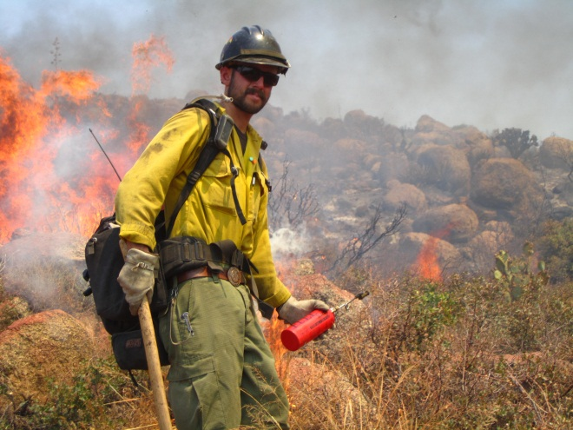
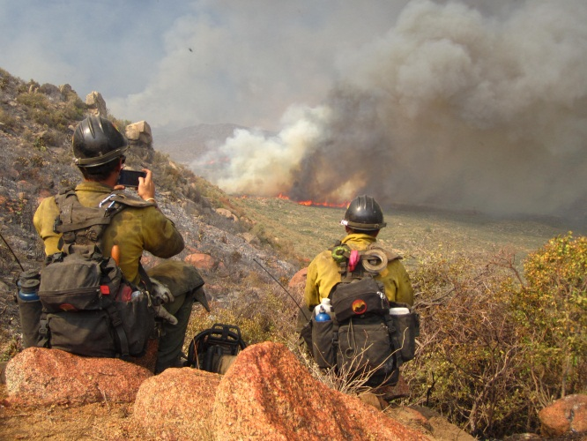
From a young age, Christopher wanted to be a fire fighter like his dad. Michael remembers Christopher worked for the U.S. Forest Service. Then moved up the latter and eventually landed a spot on the Granite Mountain Hotshot Squad.

Michael’s last communication with his son was a week before his death. They often talked on the phone. Christopher’s dad remembered they exchanged pleasantries, talked about each other’s lives, and Michael ended the conversation like he always does, “I love you. Be safe.” Christopher died a week later.

Michael first heard of the Yarnell fire when he received a phone call around midnight the day of his son’s death. He turned on the news. Michael saw that 19 firefighters had died in the fire. He quickly called Christopher’s Fire Department, with no success. He called his friend who was the captain of the Los Angeles Fire Department to try to get some answers. He finally got a number to Christopher’s fire chief. And at 3:00 a.m. Michael asked “Chris didn’t make it did he?” The fire chief responded, “No.”

Michael broke down. He was in shock. Michael immediately made reservations to fly back to California the next morning. He arrived in California to pick up Christopher’s mom, Laurie and Aaron, his other son. The funeral service in California was described as ‘incredible’ by his father. The love and support from the firefighter community was unforgettable.

Michael has had a difficult time coping with the death of his son. He doesn’t sleep anymore. He has constant anxiety and depression. Michael breaks down talking about the loss of his son. The world lost a great human being when Christopher died.

Laurie Goralski

Laurie Goralski was born in San Bernardino, California in 1951. She graduated high school and went to San Bernardino Valley College and eventually Humboldt State where she graduated with a bachelor’s degree in sociology. She has an older sister who is 72, an older brother Jerry who is 70, and a younger brother who was killed in a car accident in 2011. Laurie met Michael MacKenzie in junior college. They moved to Northern California and got married. They were together for 25 years. Laurie worked for Humboldt County, San Bernardino County, and then Riverside County for the employment services program for personal accounting. She retired in 2010. She lives in Hemet, California.

When Laurie moved back to Southern California, her husband worked at the Moreno Valley Fire Department near Riverside, California. Aaron was their first child and born on April 26, 1981. Christopher was born 17 months later. She worked 40 hours a week and raised two boys. The family moved to Hemet, California in 1986. Laurie raised her family in a firefighter community.

The two boys’ personalities were polar opposites. However, they were best friends growing up. Laurie remembered her son as an outgoing child who made friends easily. They had sleepovers with all their friends at Laurie’s home. Laurie remembered the sleepovers were always chaotic because she had to control 20 frantic boys. As a family, the Mackenzie’s went camping and took family vacations to the river. The family visited the Sierra Mountains and Mammoth in the summer time.

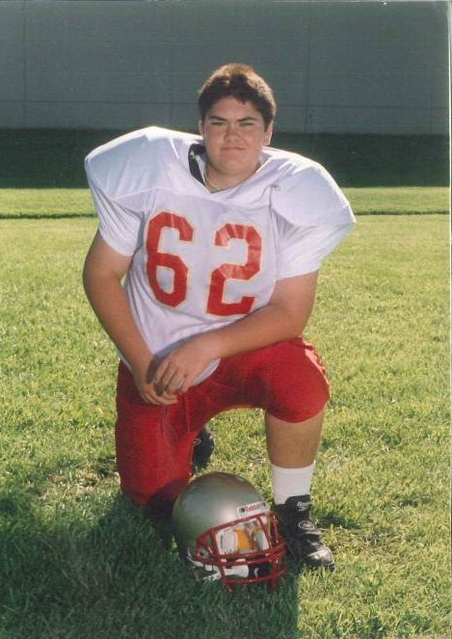
In school, Christopher was always in the advanced classes. His mother said he always made friends. He played football in high school and was always motivated to do his best. During his senior Year of high school Christopher decided he wanted to surf, skateboard and do other activities. He began working out every day and eating healthy. He loved snowboarding and after high school he worked for a Ski Resort.

His mother said Christopher loved a challenge. He always worked hard and challenged himself. Christopher and his mother were very close. They talked on the phone 3-4 times a week on the phone. She always stayed in touch with him. Laurie always wanted to know about Christopher’s newest girlfriend.

Christopher matured greatly over the last few years before he died. He was very loving and never had any problems with people. He always saw the brighter side of a situation. Christopher was a very nice guy. He was always respectful. When his mother had a brain tumor, Christopher came back, stayed, and comforted his mother during her surgery and recovery. This happened several weeks before Christopher was killed. This was just the type of guy Christopher was. He supported his family in all their endeavors and adversity they faced. It was a special moment for Christopher and his mother. His presence and support meant everything to his mother. Christopher assisted his mom throughout the brain surgery process. Laurie became very upset talking about this experience with her son. This was the last time she would see her youngest son.
Laurie’s last communication with her son was a week before his death. They talked about routine things. Christopher told her about his work on a recent fire. Laurie told him how much better she was doing. Christopher was excited to talk to his mother.

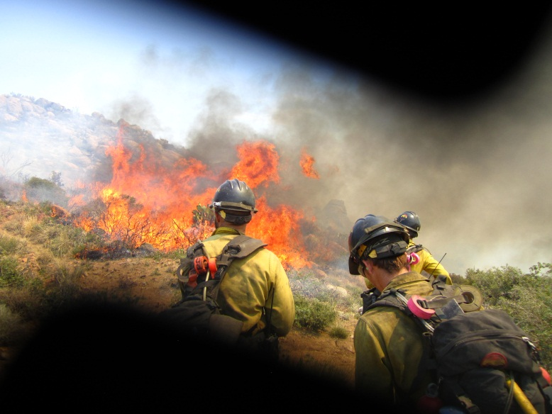
Laurie found out about the Yarnell through one of Christopher’s friends who works with the U.S. Forest Service. The friend came over to Laurie and they watched the news together. She made calls to the Prescott Fire Department. There was no answer. She later received a call her son had died. Laurie was devastated. She was in disbelief something like this could happen to her son. She has experienced depression and great anxiety. She has difficulty talking about the circumstances surrounding her son’s death.

The loss of her youngest son was an unconscionable tragedy for Laurie Goralski. The physical and emotional toll has left Laurie distraught. However, the funeral was a remarkable display of community support and compassion. The firefighting community embraced the MacKenzie family and their tragedy. Laurie lost her son, her youngest, and her best friend. She thanks God for her brain tumor because it was the last time she was able to see her son.

- Sum Certain Demand
As a result of the negligence and gross negligence of the liable public entities, the heirs of Christopher MacKenzie have experienced significant emotional pain and suffering and has lost the love, companionship, care and support of Christopher MacKenzie. In compliance with Arizona law, the heirs of Christopher MacKenzie make a sum certain demand of $10,000,000 Million and 00/100 Dollars as and for the death of Christopher MacKenzie caused by the negligence of the City of Prescott, Yavapai County and State of Arizona.

Under Arizona comparative negligence principles the public entities are free to assign and apportion fault for payment of the settlement sum as they deem fit. To the extent the recipients require formal proposed allocation of this demand, Claimant will settle for the sums certain as follows:

Michael MacKenzie:

- State of Arizona $2,000,000
- County of Yavapai $1,000,000
- Central Yavapai Fire District $1,000,000
- City of Prescott $1,000,000

Total $5,000,000

Laurie Goralski:

- State of Arizona $2,000,000
- County of Yavapai $1,000,000
- Central Yavapai Fire District $1,000,000
- City of Prescott $1,000,000

Total $5,000,000

Claimant invites the recipients to a mediation to explore non-litigated resolution to these claims as well as alternatives to monetary compensation that may assist in resolving these claims.

- Worker’s Compensation Statutes and other Immunities
Immunity from prosecution is not available to the public entities under A.R.S. § 23-1022 because: (1) the negligent actions of the liable public entities were purposefully willful; (2) the City of Prescott did not properly post the workers’ compensation election of benefits rule in the workplace of the Granite Mountain IHC, see A.R.S. §§ 23-906, 23-1022(A); (3) the intergovernmental agreement (IGA) between the City of Prescott and State of Arizona does not comply with the statutory requirements of A.R.S. § 11-952; (4) notice of the IGA was not properly posted as required, see A.R.S. § 23-1022(E); and the immunity from prosecution is not available to defendants Yavapai County, Central Yavapai Fire District nor State of Arizona. Nor are the government entities absolutely or qualifiedly immune from liability since their actions did not involve any fundamental policy decisions and given the grossly negligent manner in which the fire suppression effort was handled. It is the liable parties’ burden to demonstrate the applicability of immunity and this notice in no way forecloses other arguments available to Claimant.

- Arizona Rules of Evidence
Arizona Rules of Evidence, Rule 408 applies to this notice of claim. Nothing in this notice of claim may be used as evidence in any future judicial or administrative proceeding.

- Full Discovery/Investigation
Claimant has not had an opportunity to conduct formal discover to obtain reports, documents, statements, and information from the public entities and public employees involved in the Yarnell Hill fire and its investigations. Claimant reserves the right to supplement and amend this notice of claim should future discovery and/or disclosure determine the existence of additional facts and circumstances surrounding the Yarnell Hill Fire unknown to claimant on the day of filing her notice of claim. This Notice has been Claimant’s good faith effort to comply with the statutory claim requirements. Should the recipients perceive any legal, substantive or procedural deficiencies in this notice, Claimant should be notified immediately so that any such perceived deficiencies can be timely cured without prejudice to the recipients.

- Conclusion
This is a settlement offer. The heirs of Christopher MacKenzie will accept the sums described above (and will participate in good faith mediation to explore alternative compensation models, including non-monetary compensation) to settle all claims resulting from the intentional, willful, reckless, careless and negligent acts of the City of Prescott, Yavapai County, Central Yavapai Fire District and State of Arizona.

Thank you for your prompt attention to this matter. I look forward to your response.

Yours Truly,

THOMAS K. KELLY, P.C.

Thomas K. Kelly
Attorney at Law

ADDITIONAL CLAIMS AGAINST THE CITY OF PRESCOTT ONLY

With respect to the City of Prescott only, Claimant serves notice that, in addition to the wrongful death claims described above, Claimant intends to pursue litigation relating to the City’s wrongful classification of Christopher MacKenzie’s employment status and other conduct for the direct purpose of avoiding additional wage and benefit payments, including contribution to the Public Safety Personnel Retirement System (“PSPRS”). Pursuant to A.R.S. § 12-821.01, the following sets forth information concerning these additional claims.

- Facts upon which the employment claim is based.

Chris was one of eight Hotshots who were supervisors on the Granite Mountain crew. These were positions of authority and responsibility with associated salary increases. In connection with his promotion to Alpha Lead Crew, a supervisory position, Chris received a salary increase to $15.03 per hour. When he was hired as Alpha Lead Crew, Chris filled the position of an outgoing “full time” Hotshot.

Although Chris’s position had been approved by the Prescott City Counsel as a full-time position, the City Manager made the unilateral decision to designate Chris’s position as “temporary seasonal employee” in order to avoid paying Chris a higher salary and benefits, including:

- Health insurance;
- Paid sick leave;
- Paid vacation days; and, among other things,
- Enrollment in and contribution to the PSRS.

Instead, the City enrolled Chris in the Arizona State Retirement System (“ASRS”), the retirement system for government employees who do not regularly endanger themselves as part of their employment duties. The City did not, however, make the required federal social security administration contributions for Chris. Such contribution is required for employees, unless the employer is contributing to an alternate system such as the PSPRS.

Meanwhile, as a condition of maintaining the Granite Mountain Hotshots’ status with the federal government as an Interregional Hotshot Crew, the City verified that it in fact had eight “full time” positions on the crew. According to City records, there were only six “full time” Hotshots at this time. In other words, the City included Chris in its classification as a “full time” Hotshot to the federal government, but internally treated Chris differently for monetary reasons.

Moreover, however his employment status was characterized, the City had a duty under A.R.S. §§ 38-841 to make contributions to the PSPRS. The Legislature established the PRPRS for in order to provide “uniform, consistent and equitable” treatment of government employees “regularly assigned to hazardous duty.” A.R.S. § 38-841(B). The City is an “employer” under the PRPRS and Chris was an “employee” under the statutes. As a “municipal firefighter” regularly assigned to hazardous duty, Chris was eligible for PRPRS contributions. A.R.S. § 38-842(24)(b). The PRPRS does not require “full time,” or “non-seasonal” work as a condition of eligibility.

Chris died on June 30, 2013, at which time his family became damaged by the City’s actions, although these injuries and damages were not discovered until later.

- Liability

The City is liable for failing to appropriately classify Chris’s employment status. During 2013, Chris met the City’s own definitional criteria for “full time” employment and, conversely, was employed in a capacity inconsistent with the City’s criteria for “temporary” appointment.

Upon belief, Chris was classified as a seasonal or part-time employee in a shell game effort to allow continued non-payment of fair wages and the full complement of benefits to which he and his family was due. The City is liable for myriad breaches of duties owed to its employees, breach of duties owed under the PSPRS, breach of the implied covenant of good faith and fair dealing in an employment contract and intentional interference with contractual relationships.

Specifically, as outlined above, the City breached its duties to Chris and his family by not making required contributions to the PSPRS. In addition, by favoring its own coffers to avoid legal and valid contributions to PSPRS, the City breached its implied duty of good faith and fair dealing with its employee and also tortuously interfered with contractual relations by preventing a contract to be formed between Chris and the PSPRS. Discovery may reveal additional facts supporting other claims under local, state and/or federal law.

- Damages

As a result of the City’s actions, Chris’ family has lost valuable death benefits available through the PSPRS. Since Chris died in the line of duty but left no surviving spouse or children, his next of kin are entitled to a death benefit from PSPRS.

Claimant does not have access to all pertinent government documents relating to contribution formula so as to conduct an expert-intensive evaluation of the total economic impact of the City’s actions on her family. And because the City did not enroll Chris in the PSPRS, actual contribution figures are not available. For purposes of this demand only, Claimant assumes the death benefit that should have been owed would exceed $1,000,000.

- Sum Certain Demand

Claimant will settle all employment-related claims (exclusive of the wrongful death claims described above) against the City for the sum certain of $1,000,000. Should additional information become available or be furnished to Claimant, Claimant reserves the right to modify, increase or decrease this demand.

- Conclusion

As with the wrongful death claims, Claimant is willing to negotiate a resolution to these claims through private mediation prior to the initiation of litigation.

None of this information should be a surprise to the City, who has already met with Claimant to discuss these issues. Moreover, all documents relied upon are believed to be in possession of the City. Should the recipient feel information or documents necessary to evaluate the claim are needed, the City is invited to contact counsel immediately who will endeavor to provide any additional information in Claimant’s possession or control.

Tsk/tkk
cc: clients
J. Paladini Prescott City Atty
S. Polk, Yavapai County Atty
file

Although Christopher MacKenzie was employed by the City of Prescott, he was not an employee of Yavapai County, CYFD or the State of Arizona. And, as discussed below, exclusive remedy provisions of the workers’ compensation statutory scheme do not bar this claim. With respect to the ADOSH report’s reference to the Hotshots as state “employees”, Claimant contests that definition and assumption. However, the relevant workplace safety regulations are cited as illustrative of the applicable standard of care the recipients should have complied with in this matter.
The following list is by no means exhaustive or exclusive. New information previously unavailable to the families of lost Hotshot firefighters surfaces on an almost daily basis. Only access to witnesses, investigation documents and other materials traditionally obtained through legal discovery will allow the full extent of the liable parties’ negligence to be revealed. Thus, this claim letter is necessarily based on limited information.
These sums do not include demand for settlement of Claimant’s separate employment related claim against the City of Prescott set forth in the attached addendum.

